សាកលវិទ្យាល័យភូមិន្ទភ្នំពេញ

**ROYAL UNIVERSITY OF PHNOM PENH**

ការបង្កើត **Website** សម្រាប់ហាងទូរស័ព្ទដោយប្រើប្រាស់ **Spring Boot, Vue.js** និង **Mysql Server**

Develop An Online Store Website For Mobile Phoneshop Using Springboot, Vuejs And Mysql Server

A Report

In Partial Fulfilment of the Requirement for the Degree of

Master of Science in Information Technology Engineering

**Sen Sunneng**

**Sea Mengsrun**

**June 2025**

សាកលវិទ្យាល័យភូមិន្ទភ្នំពេញ

**ROYAL UNIVERSITY OF PHNOM PENH**

ការបង្កើត **Website** សម្រាប់ហាងទូរស័ព្ទដោយប្រើប្រាស់ **Spring** **Boot,** **Vue.js និង Mysql Server**

Develop An Online Store Website For Mobile Phoneshop Using Springboot, Vuejs And Mysql Server

A Report

In Partial Fulfilment of the Requirement for the Degree of

Master of Science in Information Technology Engineering

**Sen Sunneng**

**Sea Mengsrun**

**Examination committee:** Mr. Chhorn Silun

Mrs. Seng Molika

Mr. Chap Chanpiseth

Mr. Huon Seak

**June 2025**

# មូលន័យសង្ខេប

គម្រោងនេះបង្ហាញពីការបង្កើតនូវគេហទំព័រហាងលក់ទូរទូរស័ព្ទសម្រាប់ហាងតែប៉ុណ្ណោះ ដែលបានរចនាឡើងដើម្បីផ្តល់បទពិសោធន៍នៃការទិញទំនិញតាមអ៊ីនធឺណិតបានយ៉ាងរលូន និងមានប្រសិទ្ធភាពសម្រាប់អតិថិជន។ គេហទំព័រនេះរួមបញ្ចូលមុខងារសំខាន់ៗសម្រាប់ហាងលក់ទំនិញតាមអនឡាញ ដូចជា ការចុះឈ្មោះ និងចូលប្រើប្រាស់របស់អតិថិជន ការមើលបញ្ជីផលិតផល ការស្វែងរក ការគ្រប់គ្រងរទេះទំនិញ ការដាក់បញ្ជាទិញ និងការទូទាត់ប្រាក់តាមរយៈ KHQR ដែរ។

គេហទំព័រនេះត្រូវបានបង្កើតឡើងដោយប្រើប្រាស់ Spring Boot សម្រាប់ (backend) និង Vue.js សម្រាប់ (frontend) ដើម្បីធានាបាននូវប្រតិបត្តិការរហ័ស UI ដែល (responsive) និងអាចពង្រីកការអភិវឌ្ឍនាពេលអនាគត់។ គេហទំព័រនេះក៏មានការប្រើប្រាស់នូវប្រព័ន្ធសុវត្ថិភាពជាមួយនិង JWT Authentication និង Google OAuth ដែលអនុញ្ញាតឲ្យអ្នកប្រើប្រាស់ចុះឈ្មោះ និងចូលប្រើបានយ៉ាងងាយស្រួល។

សម្រាប់ម្ចាស់ហាង គេហទំព័រនេះមានផ្ទាំងគ្រប់គ្រង (Admin Dashboard) ដែលអាចគ្រប់គ្រងផលិតផល បញ្ជាទិញ និងតាមដានប្រតិបត្តិការបង់ប្រាក់បានយ៉ាងងាយស្រួល។ វាជាកម្មវិធីដែលផ្តោតលើអ្នកប្រើប្រាស់ និងផ្ដល់ភាពងាយស្រួលសម្រាប់ម្ចាស់ហាងផងដែរ។

គោលបំណងនៃគម្រោងនេះគឺដើម្បីជួយឲ្យហាងមួយបង្កើតវេទិកាពាណិជ្ជកម្មឌីជីថលផ្ទាល់ខ្លួន ដែលមានមុខងារពេញលេញ ងាយគ្រប់គ្រង និងមានសុវត្ថិភាព។ វាបង្ហាញថា ទោះបីជាហាងតែមួយក៏អាចប្រើប្រាស់បច្ចេកវិទ្យាឌីជីថល ដើម្បីផ្តល់បទពិសោធន៍នៃការទិញទំនិញដ៍ងាយស្រួលសម្រាប់អតិថិជន និងផ្ដល់នូវការគ្រប់គ្រងយ៉ាងពេញលេញដល់ម្ចាស់ហាងឧ្យកាន់តែងាយស្រួល និង មានប្រសិទ្ធភាពផងដែរ។

# ABSTRACT

This project presents the development of a Phone Shop Website specifically built for a **single store**, designed to provide customers with a seamless and efficient online shopping experience. The system includes all the core features required for a modern online shop such as user registration and login, product catalog browsing, search and filtering, shopping cart management, order placement, and secure KHQR-based payment.

Built with **Spring Boot** for the backend and **Vue.js** for the frontend, the application ensures high performance, a responsive user interface, and easy future scalability. The platform includes secure login mechanisms using **JWT authentication** and **Google OAuth**, allowing users to register and log in safely and conveniently.

For store management, the system includes an **admin dashboard** where the store owner can manage products, process orders, and monitor transactions. This makes the platform both customer-focused and store-owner-friendly.

The goal of this project is to help one business establish its digital presence with a fully functional, maintainable, and secure online store. It proves that even a single store can take full advantage of digital commerce by offering customers a professional shopping experience and giving the business owner powerful tools to manage operations effectively.

# SUPERVISOR’S RESEARCH SUPERVISION STATEMENT

TO WHOM IT MAY CONCERN

Name of program: Bachelor of Engineering in Information Technology Engineering

Name of candidate: **SEN SUNNENG & SEA MENGSRUN**

Title of research report: Develop a Website For a Phone Store with backend: springboot, front: vue.js, DB: MySQL

This is to certify that the research carried out for the above titled Bachelor’s research report was completed by the above named candidate under my direct supervision. This report material has not been used for any other degree. I played the following part in the preparation of this report:

• Provided academic supervision and guidance throughout the report development process.

• Assisted in defining the scope, structure, and content of the report.

• Reviewed the work to ensure it meets academic standards and formatting requirements.

Supervisor's name: **CHHIM BUNCHHUN**

Supervisor’s signature:……………………

Date……………………………………………

# CANDIDATE’S STATEMENT

TO WHOM IT MAY CONCERN

This is to certify that the report entitled **"Development of a Secure and Scalable   
E-Store System Using Spring Boot and Vue.js"**, submitted in partial fulfillment of the requirements for the degree, has been completed solely by us, **Sen Sunneng** and **Sea Meng Srun**.

for the degree of Master of Science at the Royal University of Phnom Penh is entirely my own work and, furthermore, that it has not been used to fulfill the requirements of any other qualification in whole or in part, at this or any other University or equivalent institution.

No reference to, or quotation from, this document may be made without the written approval of the author.

Signed by: **SEN SUNNENG & SEA MENGSRUN**

Candidate’s signature:……………………………...

Date: ……………………………………………….

Sign by Supervisor: **CHHIM BUNCHHUN**

Supervisor’s signature: ………………………….…

Date…………………………………………..……

# ACKNOWLEDGNENTS

First and foremost, I would like to express my deepest gratitude to my supervisor, Mr Chhim Bunchhun, for their invaluable guidance, support, and encouragement throughout the development of this project. Their insights and feedback have been essential to the successful completion of my E-Store Website.

I am also sincerely thankful to all the lecturers and staff of the Information Technology Engineering, Royal University of Phnom Penh, for providing me with the knowledge and resources needed during my studies.

Special thanks go to my family and friends for their continuous support, patience, and motivation throughout this academic journey. Their encouragement helped me overcome challenges and stay focused on my goals.

Lastly, I would like to thank everyone who contributed directly or indirectly to the success of this project. Your help and support are truly appreciated.

TABLE OF CONTENT

មូលន័យសង្ខេប i

ABSTRACT ii

SUPERVISOR’S RESEARCH SUPERVISION STATEMENT iii

CANDIDATE’S STATEMENT iv

ACKNOWLEDGNENTS v

CHAPTER 1 1

1.1 Background to the Study 1

1.2 Problem Statement 1

1.3 Aim and Objectives of the Study 2

1.3.1 Aim: 2

1.3.2 Objectives: 2

1.4 Rationale of the Study 3

1.5 Limitation and Scope 4

1.5.2 Limitations 4

1.6 Structure of the Study 5

CAHPTER 2 6

2.1 Overview of E-Commerce Systems 6

2.2 Technologies Used in Development 6

2.3 Previous Studies and Related Work 7

2.4 Summary of Key Findings 9

CAHPTER 3 10

3.1 Research Design 10

3.2 System Architecture 10

3.3 Development Tools and Technologies 11

3.4 Implementation Process 15

3.4.1 Use Case Diagram 16

3.4.2 System Architecture 18

3.4.3 Database Design 21

CAHPTER 4 23

4.1 Overview of Functional Features 23

4.2 Screenshot of Website 24

4.3 Performance Evaluation 49

4.4 Summary of Results 49

CAHPTER 5 50

5.1 Interpretation of Results 50

5.2 Challenges Faced During Development 50

5.3 Comparison with Existing Systems 51

CHAPTER 6 55

6.1 Summary of the Study 55

6.2 Recommendations 55

6.3 Future Work 56

REFERENCES 57

APPENDIXES 58

# CHAPTER 1

**INTRODUCTION**

## 1.1 Background to the Study

In recent years, the rapid advancement of internet technologies and the widespread adoption of smartphones have significantly transformed how people conduct business and shop for goods and services. E-commerce has emerged as a vital platform, enabling businesses to reach a wider audience, operate more efficiently, and offer customers the convenience of shopping anytime, anywhere. This shift became even more prominent during the COVID-19 pandemic, which emphasized the importance of digital platforms in maintaining business continuity (United Nations Development Programme, n.d.; World Bank, n.d.).

In Cambodia and other developing countries, online commerce has been steadily expanding, with more consumers embracing digital payments and online transactions (Khmer Times, 2025; ASEAN Access, 2025). However, many local businesses still lack the technical resources and expertise needed to develop and maintain effective e-commerce platforms that meet modern standards of usability, security, and scalability (Activerify, n.d.; Loma Technology, n.d.).

This project—a single-store E-Store Website—was initiated to address this gap by designing and implementing a fully functional, user-friendly, and secure online shopping system. The application is built using Spring Boot for the backend and Vue.js for the frontend and includes essential features such as user authentication, product Browse, shopping cart management, order processing, and KHQR-based digital payment integration (National Bank of Cambodia, n.d.). The project aims to demonstrate how modern web technologies can support business digitalization, enhance customer experience, and improve overall business performance in today’s competitive digital economy.

## 1.2 Problem Statement

Despite the global expansion of e-commerce, many small and medium-sized enterprises (SMEs) in Cambodia continue to rely heavily on traditional in-store sales. This dependency limits their market reach and revenue potential. A major barrier to digital adoption is the lack of accessible, user-friendly, and affordable e-commerce platforms, preventing these businesses from participating effectively in the digital economy (Activerify, n.d.; Loma Technology, n.d.).

Existing online shopping solutions are often either expensive to develop and maintain or lack critical features such as support for local payment methods, Khmer language integration, and adaptability to local business models. Additionally, some platforms are too complex for store owners with limited technical knowledge, making it difficult to manage products, process orders, or engage with customers effectively.

This project aims to address these challenges by developing a tailored E-Store Website that is simple, scalable, and aligned with the needs of the local market. The system includes essential features such as user registration, product listings, shopping cart functionality, checkout, and KHQR payment integration (National Bank of Cambodia, n.d.). By doing so, it seeks to empower Cambodian SMEs to operate online easily and expand their customer base without requiring advanced technical skills or large financial investment.

## 1.3 Aim and Objectives of the Study

### 1.3.1 Aim:

The primary aim of this study is to design and develop a user-friendly, secure, and scalable E-Store Website that facilitates online shopping for customers and provides local businesses with an efficient platform to manage their products and orders.

### 1.3.2 Objectives:

To achieve this aim, the study focuses on the following specific objectives:

* To analyze the requirements for an effective e-commerce platform suitable for small and medium-sized businesses in a local context.
* To design and implement a responsive front-end interface using Vue.js that provides customers with an intuitive and accessible shopping experience. (247 Commerce, 2024).
* To develop a secure and robust backend using Spring Boot that handles user management, product operations, and order processing efficiently (Java Guides, 2024; Krishnamurtyp, n.d.).
* To integrate a local digital payment system, such as KHQR (National Bank of Cambodia, n.d.), for smooth and secure transactions.
* To implement an admin dashboard for managing products, users, and orders in a simple and organized manner.
* To test and evaluate the performance, usability, and reliability of the website through various scenarios and user feedback.
* To provide documentation and recommendations for future improvements and deployment of the system in real business environments.

## 1.4 Rationale of the Study

As digital transformation continues to reshape global commerce, the need for effective online business platforms has become increasingly important. In Cambodia, many small and medium-sized enterprises (SMEs) face challenges in adopting digital sales channels due to limited technical resources, lack of access to suitable platforms, and unfamiliarity with e-commerce technologies (Activerify, n.d.; Loma Technology, n.d.; NIRONT Marketplace, 2025).

This study is important because it addresses a practical need for a simple, secure, and locally-adapted e-commerce solution. By developing an E-Store Website tailored to the Cambodian context—including KHQR payment integration (National Bank of Cambodia, n.d.)—this project aims to empower businesses to participate in the digital economy more effectively.

Furthermore, the study contributes to academic learning by allowing the application of modern web technologies such as Spring Boot and Vue.js in a real-world system (Java Guides, 2024; Krishnamurtyp, n.d.). It offers hands-on experience in full-stack development, secure authentication (Timus Networks, n.d.), and system deployment, which are essential skills for a career in software engineering.

In summary, this project provides both social and educational value: it helps local businesses overcome barriers to online commerce and offers a practical learning opportunity for the student.

## 1.5 Limitation and Scope

#### **1.5.1 Scope**

This project focuses on the development of a web-based E-Store platform that allows users to browse products, add them to a shopping cart, place orders, and make payments via KHQR (National Bank of Cambodia, n.d.). The system also includes an admin dashboard where administrators can manage users, products, and orders. The front-end is developed using Vue.js, while the backend is built with Spring Boot. The platform is designed for small to medium-sized businesses looking to sell products online in the Cambodian market. Key features within scope include:

* User authentication (sign-up, login, logout)
* Product listing and search functionality
* Shopping cart and order placement
* KHQR payment integration (National Bank of Cambodia, n.d.)
* Admin panel for managing products, orders, and users
* Responsive design for both desktop and mobile devices (247 Commerce, 2024)

### 1.5.2 Limitations

* The system is web-based only and does not include a mobile application.
* Payment integration is limited to KHQR; other methods like credit cards or international gateways are not supported.
* The recommendation system (if any) is basic and does not use advanced algorithms like machine learning.
* The platform is designed for general product sales and may require further customization for specific industries (e.g., food delivery, fashion, services).
* The system has been tested in a simulated environment; real-world deployment would require further security auditing and performance optimization.

## 1.6 Structure of the Study

This report is structured into six main chapters, each of which contributes to the overall understanding, development, and evaluation of the E-Store Website project:

* Chapter 1: Introduction Provides an overview of the study, including the background, problem statement, aim and objectives, rationale, limitations, and the structure of the report itself.
* Chapter 2: Literature Review Reviews relevant literature, theories, and technologies related to e-commerce systems. It covers existing platforms, development tools, design approaches, and related studies to establish a foundation for the project.
* Chapter 3: Methodology Describes the development process, tools, frameworks, and system architecture used in building the E-Store Website. It explains the steps taken to design, implement, and test the system.
* Chapter 4: Data Analysis and Results Presents the results of the system implementation, including screenshots of the interface, explanation of key features, and any data collected during system testing.
* Chapter 5: Discussion Analyzes the results, discusses the effectiveness of the developed system, highlights challenges encountered during development, and compares the solution with existing alternatives.
* Chapter 6: Conclusion Summarizes the study, presents the main findings, and offers recommendations for future improvements or expansions of the system.

# CAHPTER 2

**LITURATURE REVIEW**

### 2.1 Overview of E-Commerce Systems

E-commerce, short for electronic commerce, refers to the buying and selling of goods and services over the internet. It has revolutionized how businesses operate, allowing for greater accessibility, convenience, and reach. E-commerce systems can be classified into several types, including Business-to-Consumer (B2C), Business-to-Business (B2B), Consumer-to-Consumer (C2C), and Consumer-to-Business (C2B).

In a typical B2C model—which this project adopts—customers interact directly with the store through a web interface where they can browse products, add them to a cart, make payments, and track their orders. Key components of such systems include product catalogs, user authentication, shopping carts, order management, and payment gateways.

As digital infrastructure improves in countries like Cambodia, more consumers and businesses are transitioning to online platforms (Khmer Times, 2025; ASEAN Access, 2025). However, challenges such as limited technical skills, lack of tailored solutions, and limited access to secure online payments still remain significant barriers to adoption (Activerify, n.d.; Loma Technology, n.d.).

### 2.2 Technologies Used in Development

The development of modern e-commerce platforms involves a variety of technologies across both the frontend and backend.

* Frontend (Client-Side): The frontend of this website is developed using Vue.js, a progressive JavaScript framework known for its reactive data binding and component-based architecture. It is suitable for creating dynamic and responsive user interfaces that provide a smooth shopping experience (247 Commerce, 2024).
* Backend (Server-Side): The backend uses Spring Boot, a Java-based framework that simplifies the development of robust and scalable RESTful web services. It handles business logic, user management, product processing, and integration with the database (Java Guides, 2024; Krishnamurtyp, n.d.).
* Database: A relational database (e.g., MySQL or PostgreSQL) is used to store information about users, products, and orders (Krishnamurtyp, n.d.). The database supports CRUD (Create, Read, Update, Delete) operations managed through the backend.
* Payment Integration: The system integrates KHQR, a Cambodian QR code payment standard that facilitates secure and convenient digital transactions (National Bank of Cambodia, n.d.). This ensures that the platform aligns with local financial practices.
* Security: Security practices such as JWT (JSON Web Tokens) for authentication and HTTPS for secure communication are applied to protect user data and transactions (Timus Networks, n.d.).

### 2.3 Previous Studies and Related Work

To understand the current landscape of e-store platforms within Cambodia's tech accessories market, three local websites were analyzed. These include ccComputer , Sokly, and Nika. Each offers varying degrees of interactivity and payment functionality. The findings are summarized in the table below:

|  |  |  |  |  |
| --- | --- | --- | --- | --- |
| |  | | --- | | **Website Name** | | Description | Payment Available | Findings |
| ccComputer | |  | | --- | | Tech store offering computers and accessories. | | No | |  | | --- | | Traditional user interface with limited interactivity. Lacks full e-commerce functionalities such as integrated cart, checkout, or online payments. | |
| Sokly | Electronics and mobile device store. | No | |  | | --- | | Supports online ordering, but lacks live KHQR (Khmer QR code) payment integration. The checkout process relies  on offline or manual confirmation. | |
| Nika | |  | | --- | | Mobile-first electronics store with a loyalty and membership system. | | Yes | |  | | --- | | Offers an active mobile app experience. While payments are supported, it’s unclear whether KHQR is fully integrated into the platform. | |

*Table 1: Cambodian E-Store Platforms*

This Table 1, titled "Cambodian E-Store Platforms," provides a comparative analysis of three prominent local e-commerce websites: ccComputer, Sokly, and Nika. The objective of this analysis is to delineate the current landscape of digital commerce in Cambodia, specifically identifying the existing functionalities and limitations within these platforms, which in turn informs the development of a new e-store solution.

Each column in the table conveys distinct information:

* Website Name: This column serves as a direct identifier for each e-commerce platform under review.
* Description: This section offers a succinct overview of the primary business focus or offerings of each website, providing context for their operational scope.
* Payment Available: This critical column indicates whether the respective platform incorporates integrated online payment functionalities ("Yes" or "No"). This highlights their capacity for automated transaction processing.
* Findings: This comprehensive section elaborates on specific observations regarding each platform's user interface, interactivity, and the extent of their e-commerce functionality, with particular attention to payment integration and overall user experience.

**Detailed Observations from the Table:**

* ccComputer: This platform, a tech store for computers and accessories, is characterized by a traditional user interface with limited interactivity. A significant finding is its lack of comprehensive e-commerce functionalities, specifically an integrated shopping cart, a streamlined checkout process, and any form of online payment system. This suggests it operates more as a digital catalog rather than a transactional e-store.
* Sokly: Positioned as an electronics and mobile device store, Sokly supports online ordering, allowing users to select products. However, a key limitation identified is the absence of live KHQR (Khmer QR code) payment integration. Its checkout process necessitates offline or manual confirmation for payments, which can introduce friction and delay in the transaction flow.
* Nika: This platform is described as a mobile-first electronics store, distinguished by its inclusion of a loyalty and membership system. While it does support online payments, the analysis reveals ambiguity regarding the full integration of KHQR, suggesting that its payment solutions might not be specifically tailored to local Cambodian standards or are not transparently implemented.

**Significance of the Analysis for the Report:**

This comparative analysis is instrumental in contextualizing the study's objectives. It highlights critical gaps in the existing Cambodian e-commerce market, particularly the limited availability of fully integrated online payment solutions like KHQR and comprehensive, user-friendly e-commerce functionalities within local platforms. These identified deficiencies underscore the necessity and relevance of developing a new e-store system that directly addresses these unfulfilled needs, thereby enhancing the digital adoption capacity for small and medium-sized businesses in the region.

## 2.4 Summary of Key Findings

From the review of literature and related projects, several insights have emerged:

* A successful e-store system must balance functionality, ease of use, and security.
* Vue.js and Spring Boot are proven technologies that offer speed, flexibility, and scalability for web-based e-store applications (Java Guides, 2024; Krishnamurtyp, n.d.).
* Local payment integration (such as KHQR in Cambodia) is essential to increase trust and usability among local consumers (National Bank of Cambodia, n.d.).
* Providing a user-friendly admin dashboard is crucial for small businesses that may not have technical teams to manage complex platforms.
* Prior studies support the use of component-based and RESTful architectures for modular, maintainable, and scalable system design.

These findings provide a strong foundation and justification for the technological and functional decisions made in this project.

# CAHPTER 3

**METHODOLOGY**

### 3.1 Research Design

This study adopts a practical, project-based research design focused on the development of a functional e-store web application. The project follows the Agile software development methodology (ASEAN Access, 2025), which emphasizes iterative development, continuous feedback, and flexibility in incorporating changes during the development process.

The primary goal is to design, implement, and evaluate an E-Store Website tailored for small to medium-sized businesses in Cambodia. The project is broken down into multiple phases:

* Requirements gathering and analysis
* System design
* Development and coding
* Testing and evaluation
* Documentation and deployment

This methodology allows for continuous improvement of the system based on testing and evaluation results, ensuring that the final product meets its intended purpose.

### 3.2 System Architecture

The architecture of the E-Store Website is based on a client-server model and follows a three-tier architecture: Presentation Layer, Business Logic Layer, and Data Layer (Krishnamurtyp, n.d.).

* Presentation Layer (Frontend): This layer provides a responsive and interactive user interface where customers can browse products, place orders, and make payments. It communicates with the backend through RESTful APIs (247 Commerce, 2024).
* Business Logic Layer (Backend): This layer handles all server-side operations including user authentication, product management, order processing, and payment integration. It exposes APIs that the frontend consumes (247 Commerce, 2024).
* Data Layer (Database): A relational database (e.g., MySQL or PostgreSQL) is used to store structured data such as user accounts, product information, order details, and payment transactions (Krishnamurtyp, n.d.).
* Security: JWT-based authentication (Timus Networks, n.d.) ensures secure access to protected resources. HTTPS (Timus Networks, n.d.) is used to encrypt data in transit.
* KHQR Payment Integration: The backend generates KHQR codes for payment and verifies transaction status to complete orders securely (National Bank of Cambodia, n.d.).

### 3.3 Development Tools and Technologies

Several modern development tools and technologies were used throughout the project:

#### **3.3.1 Frontend:**

The frontend of the E-Store system was developed using modern web technologies focused on performance, user experience, and maintainability. Below are the key tools and libraries utilized:

* Vue.js: The primary JavaScript framework used for building the frontend. It offers a reactive, component-based architecture that enhances modularity and promotes efficient development of dynamic user interfaces.
* Tailwind CSS: Used for styling and layout. It provides a utility-first approach to CSS, allowing rapid and responsive design implementation directly in the HTML templates without writing custom CSS.
* Axios: A promise-based HTTP client used to send asynchronous requests to the backend API. It handles all data communication between the frontend and backend services.
* Universal-Cookie: Employed for managing authentication tokens via browser cookies. It ensures persistent session management and secure storage of tokens across pages.
* Vue Toastification: Used to display non-intrusive toast notifications for system feedback, such as success, error, or warning messages. It enhances the user experience by providing real-time, visual responses to user actions.
* Pinia: The state management library used in this project. It allows sharing and managing global application state in a scalable way, serving as the central store for components to access and mutate shared data.
* qrcode.vue: The component integrated to generate and display QR codes directly within the interface. This is particularly useful for visualizing payment codes, including KHQR for Bakong transactions.

#### **3.3.2 Backend:**

* Spring Boot: Serves as the foundation for the backend application. It simplifies the setup and development of Java-based applications by providing a production-ready framework with embedded servers and auto-configuration capabilities. The application follows a RESTful architecture (247 Commerce, 2024) to expose APIs for the frontend to consume.
* Spring Security: Integrated to provide robust authentication and authorization mechanisms. It supports both form-based and token-based (JWT) authentication, including OAuth2 for third-party login via Google.
* Spring Data JPA (Hibernate): Used for interacting with the MySQL database (Krishnamurtyp, n.d.). It simplifies CRUD operations and abstracts the complexity of data access using repositories.
* JWT (JSON Web Tokens): Used for stateless user authentication. The implementation includes dependencies for creating, parsing, and verifying tokens securely.
* OpenAPI (SpringDoc): Used to document and test RESTful APIs. It automatically generates Swagger UI from annotations in the controller layer, making the APIs more accessible to developers and testers.
* Bakong SDK: The official Bakong KHQR SDK is integrated to enable KHQR code generation and payment processing, aligning with local Cambodian digital payment standards (National Bank of Cambodia, n.d.).
* Email Service: Used to send email notifications, such as order confirmations and invoices. The service is configured with SMTP properties.
* PDF Generation (iText): The library used for dynamically generating PDF invoices, which can be attached to emails or downloaded by users.
* Google OAuth Client: Libraries utilized to allow users to authenticate using their Google accounts, simplifying user sign-in/sign-up processes.

#### **3.3.3 Database:**

MySQL was chosen as the database management system for this project (Krishnamurtyp, n.d.). It is a robust, open-source relational database that efficiently handles structured data and supports SQL for querying and managing data. MySQL is well-suited for the E-Store application due to its reliability, scalability, and strong support for transactions and relational integrity (Krishnamurtyp, n.d.), which are essential for managing products, users, orders, and payment records.

#### **3.3.4 Development & Deployment:**

* IntelliJ IDEA: Backend development environment.
* Datagrip: Used for database management.
* Visual Studio Code: Frontend development environment.
* Postman: Used for testing API endpoints.
* GitHub: Used for version control.
* Docker (12): Used for containerizing the application.
* DigitalOcean: Used for deployment and hosting.
* Google Cloud Console: Used for Google Map OAuth authentication.

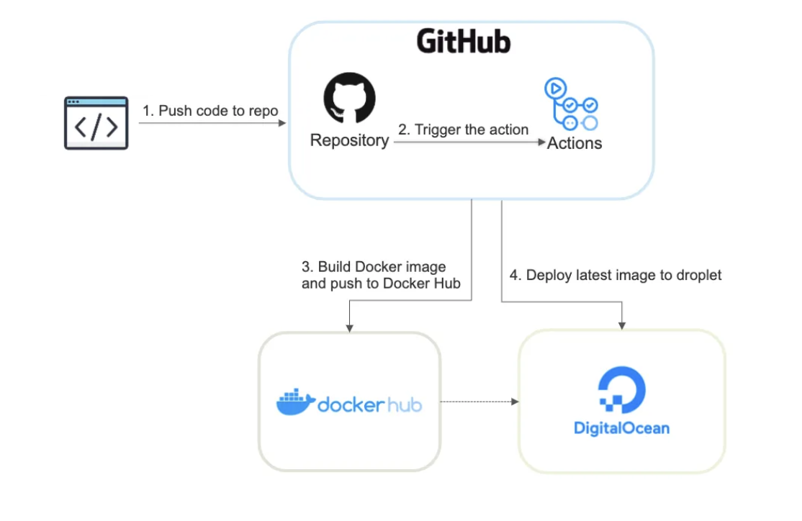

*Figure1 : Process Deployment*

**Figure 1: Process Deployment**

Figure 1: Process Deployment Overview The pipeline consists of four sequential stages triggered by code changes:

* **Code Commit to GitHub Repository:** Developers push application code to a designated GitHub repository. This action serves as the pipeline trigger. The repository must contain:
  + Application source code
  + Dockerfile defining the container environment
  + GitHub Actions workflow configuration (YAML file)
  + Any required dependencies or configuration files
* **GitHub Actions Execution:** The code push event automatically triggers predefined GitHub Actions workflows. These execute on GitHub-hosted Linux runners and perform:
  + Code checkout from the repository
  + Environment setup and dependency installation
  + Execution of test suites (if configured)
  + Preparation for containerization
* **Docker Image Build and Registry Push:** The workflow builds a Docker container image (Krishnamurtyp, n.d.) using the repository's Dockerfile, then pushes it to Docker Hub with versioned tags. Critical steps include:
  + Authenticating to Docker Hub using encrypted secrets
  + Building the container image with unique tags (e.g., latest and Git commit SHA)
  + Pushing the validated image to a private/public Docker Hub repository
  + Generating build artifacts and logs for auditing
* **DigitalOcean Droplet Deployment:** The workflow securely connects to the production Droplet via SSH and executes deployment commands:
  + Pulling the latest Docker image (Krishnamurtyp, n.d.) from Docker Hub
  + Stopping and removing previous containers
  + Launching the new container with updated configuration
  + Verifying service health through status checks

## 3.4 Implementation Process

The development of the E-Store Website followed a modular and incremental approach (ASEAN Access, 2025):

* Requirement Analysis: Identified core features needed by users and administrators, such as product browsing, order placement, user login, and KHQR payments.
* System Design: Created wireframes and designed the database schema (Krishnamurtyp, n.d.) and API endpoints (247 Commerce, 2024). The system architecture and component layout were defined.
* Frontend Development: Built reusable components such as product cards, shopping cart, order forms, and user dashboard using Vue.js and Tailwind CSS.
* Backend Development: Developed API endpoints using Spring Boot for user management, order processing, and product CRUD operations. Integrated KHQR payment handling (National Bank of Cambodia, n.d.) and applied JWT for secure login (Timus Networks, n.d.).
* Deployment: The system was containerized using Docker (Krishnamurtyp, n.d.) and configured with Nginx as a reverse proxy to handle web traffic efficiently. A CI/CD pipeline (World Bank, n.d.) was implemented via GitHub Actions to automate the build, test, and deployment processes. The entire application was deployed on a DigitalOcean server, enabling reliable demonstration, scalability, and further testing.

This process ensured that each module was properly tested and integrated before moving on to the next, resulting in a stable and functional application.

### 3.4.1 Use Case Diagram

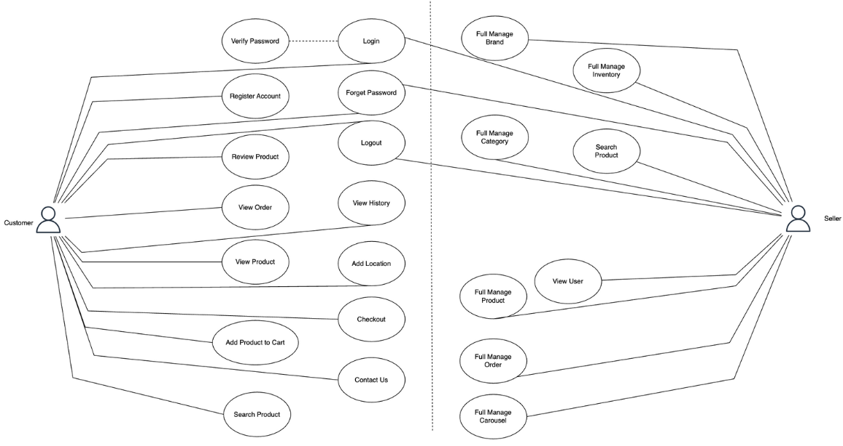

*Figure2 : Use Case Diagram*

**Figure 2: Use Case Diagram**

**Guest (Unregistered User)**

Purpose: Enable exploratory access to core shopping features without account commitment, reducing onboarding friction. Functional Capabilities:

* Register Account: account creation through email and password, Or use Oauth Login with google account,
* Search Product: Perform keyword-based searches with price/category filters. Excludes members-only products and personalized recommendations.
* View Product: Access product details including specifications, images, and pricing. Cannot view real-time stock levels.
* Review Product (Read-only): Browse ratings and user-generated reviews. Submission functionality disabled.
* Add Product to Cart: Can’t add to cart unless Login.

**Customer (Registered User)**

Purpose: Deliver personalized shopping experiences with persistent data storage and transaction capabilities. Inherited Capabilities: Retains all Guest functionality except registration, with enhanced Review Product privileges (read/write access). Enhanced Capabilities:

* Login/Logout: JWT-based authentication (Timus Networks, n.d.)..
* Forget Password: can reset password with email verify.
* View History: Access complete order history and ongoing order with the status of the order.
* Add Location: add delivery addresses with Google Maps.
* Checkout: PCI-compliant payment processing with address verification pay with KHQR.
* Editor: Profile management.
* Review Product: Submit ratings (1-5 stars).

**Admin/Seller**

Purpose: Govern end-to-end platform operations with full system oversight and business workflow control. Inheritance: Full access to all Customer capabilities plus privileged overrides (e.g., view/edit any user's orders). Exclusive Capabilities:

* Manage Product: Seller can add, update/Edit, search or delete Product also
* Manage Brand: CRUD operations for brand entities.
* Manage Inventory: Can update stock of the product that have low stock manual.
* Manage Category: Can add delete and edit the category.
* Manage Order: Can view and update the status of the product.
* User Management: Role assignments and delete the user.

### 3.4.2 System Architecture

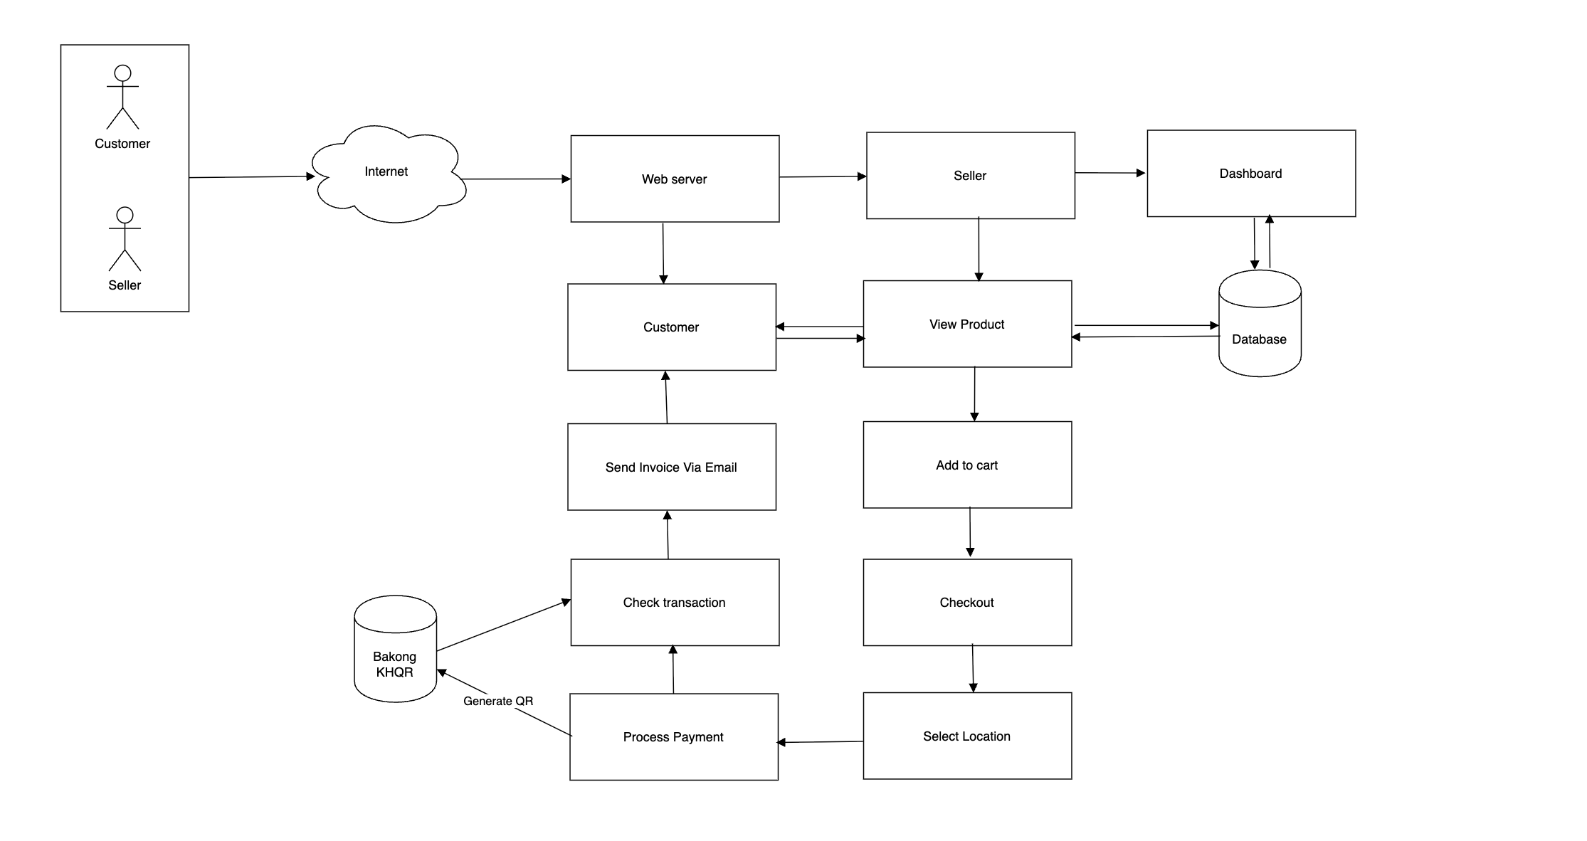

*Figure3: System Architecture(process buying)*

**Figure 3: System Architecture (process buying)**

System Architecture Overview The e-commerce platform is designed to support two primary user roles—Customers and Sellers—with the unique capability for sellers to also act as customers. The system integrates Bakong KHCR (National Bank of Cambodia, n.d.), Cambodia’s QR-based payment system, for seamless transactions in Khmer Riel (KHCR). Below is a detailed breakdown of the architecture:

**Core Components**

* **Customer:** The end-user who browses products, adds items to a cart, and completes purchases. Customers interact with the platform via a frontend interface, which communicates with the Web Server to fetch product data, process payments, and confirm orders.
* **Seller (Dual-Role):** Sellers operate in two modes: **Seller Mode:** Manages inventory, monitors orders, and views sales analytics through a dedicated Dashboard. **Customer Mode:** Switches to a buyer role to purchase products (from other sellers or the platform), following the same workflow as regular customers.
* **Web Server:** Acts as the central hub for handling HTTP requests, including product searches, cart updates, checkout processes, and payment validations. It interfaces with the Database and external APIs (e.g., Bakong KHCR ((National Bank of Cambodia, n.d.))).
* **Database :** Stores all critical data: product listings, user profiles, cart sessions, order histories, and transaction records (Krishnamurtyp, n.d.). Designed to support high concurrency for e-commerce operations.
* **Bakong KHCR (**(National Bank of Cambodia, n.d.)**):** The payment gateway responsible for generating QR codes, processing transactions in KHCR, and validating payment success. Integrated via Bakong’s API for real-time payment confirmation.
* **Dashboard:** A seller-exclusive interface for managing products (add/edit/remove), tracking orders, and viewing financial transactions. Built to ensure sellers can efficiently oversee their business operations.
* **Email Service:** Automates transactional emails, such as order confirmations and payment invoices, triggered post-checkout. Ensures users receive timely updates.

**Workflow A. Customer/Seller-as-Customer Journey**

* **Product Browsing:** Customers (or sellers in Customer Mode) view product listings fetched from the Database (Krishnamurtyp, n.d.).
* **Cart Management:** Selected items are stored in the user’s cart (persisted in the Database (Krishnamurtyp, n.d.)).
* **Checkout:** Users select delivery options and initiate payment.
* **Payment Processing:** The Web Server generates a Bakong KHCR (National Bank of Cambodia, n.d.). QR code for scanning and payment.
* **Transaction Validation:** The system confirms payment success via Bakong’s API (5) and updates the order status.
* **Confirmation:** An invoice is sent via email, and the order is logged in the Database (9). B. Seller-Centric Workflow
* **Dashboard Access:** Sellers log in to manage their storefront.
* **Inventory Management:** Sellers add or modify products, which are stored in the Database (Krishnamurtyp, n.d.).
* **Order Fulfillment:** The Dashboard displays orders placed by customers (or other sellers).
* **Payment Monitoring:** Sellers track completed transactions and revenue via Bakong-integrated reports (Krishnamurtyp, n.d.).

**Key Features**

* **Role Switching:** Sellers toggle between Seller Mode (management) and Customer Mode (shopping) via a UI control, with session-based permissions to prevent conflicts.
* **Unified Cart & Checkout:** Both customers and sellers-in-Customer-Mode share the same purchase pipeline, reducing code redundancy.
* **Payment Security:** Bakong KHCR’s API (National Bank of Cambodia, n.d) ensures encrypted, real-time payment validation.
* **Data Isolation:** The Database (Krishnamurtyp, n.d.) tags orders with buyer/seller IDs to maintain clear audit trails.

This architecture provides a robust foundation for your e-commerce platform, balancing flexibility (dual-role sellers), security (Bakong payments), and scalability.

### 3.4.3 Database Design

*Figure4: Database Design*

**Figure 4: Database Design**

* **Product:** productID (PK), brandID (FK) → Brand, categoryID (FK) → Category. Fields include: model, description, price, stock, average_rating, release_date_at.
* **Brand:** brandID (PK). Fields include: name, description, image_url.
* **Category:** categoryID (PK). Fields include: name, description.
* **Product_Detail:** ID (PK), productID (FK) → Product. Fields include: display, performance, camera, battery, connectivity, build_and_design, software, other_features.
* **Additional_Info:** ID (PK), productID (FK) → Product. Allows for dynamic product specs via info_key and info_value.
* **Inventory:** inventoryID (PK), productID (FK) → Product. Fields include: model, status, stock, image_url, last_update_at.
* **User:** userID (PK). Fields include: first_name, last_name, email, password, address, image_url, role (ENUM like "customer", "admin"), created_at.
* **Review:** reviewID (PK), productID (FK), userID (FK). Fields include: comment, rating, stock (possibly typo), image_url, last_update_at.
* **Cart:** cartID (PK), userID (FK) → User. Field: total_price.
* **CartItem:** cart_itemID (PK), productID (FK) → Product. Field: quantity. Linked to Cart via one-to-many relationship.
* **Order:** orderID (PK), userID (FK) → User, cartID (FK) → Cart, paymentID (FK) → Payment. Fields include: status, md5 (likely for hashing), invoice_sent, created_at.
* **Payment:** paymentID (PK). Fields include: status, total_amount, created_at.
* **Slide:** slideID (PK). Fields include: title, image_url, description.

**Relationships Summary**

* One Brand → Many Products
* One Category → Many Products
* One Product → Many Product_Detail, Additional_Info, Reviews, Inventory
* One User → Many Reviews, Orders, Carts
* One Cart → Many CartItems
* One Payment → Many Orders

**Overall Purpose**

This schema supports a full e-commerce flow (9):

* Browsing products (with detailed specs and reviews).
* Adding products to cart.
* Managing inventory.
* Processing orders and payments.
* User accounts and roles.
* Displaying homepage slides.

# CAHPTER 4

**RESULT**

## 4.1 Overview of Functional Features

The developed E-Store system provides a range of functionalities designed to enhance user experience and facilitate seamless e-commerce operations. The core features include:

* **User Authentication and Authorization**: The application supports secure login and registration processes using Spring Security with JWT-based authentication .Google OAuth is also integrated for simplified sign-in using Google accounts.
* **Product Management**: Admin users can add, update, or delete products via a secure backend . Each product can include details such as name, price, description, category, image, and available stock.
* **Product Browsing and Filtering**: Customers can browse products by categories, seasons, and tags. Real-time filtering and search functionality improve the navigation experience.
* **Shopping Cart and Checkout**: Users can add items to their cart and proceed to checkout. The system calculates totals and includes QR code-based payment options using Bakong KHQR integration.
* **QR Code Payment Integration**: The application supports KHQR payments by generating a unique QR code for each transaction using the Bakong SDK​ .
* **Order and Invoice Generation**: Upon successful checkout, a digital invoice in PDF format is generated using iTextPDF and sent automatically to the customer’s email.
* **Sales Dashboard and Analytics**: Admins can view sales data represented in graphs for daily, weekly, and monthly summaries.
* **Responsive and Interactive Frontend**: Built using Vue.js and Tailwind CSS, the frontend is optimized for desktop and mobile views with state management handled by Pinia and visual alerts by Vue Toastify.

## 4.2 Screenshot of Website

*Figure 5: Home Page*

**Figure 5 : Home Page User Interface**

This report outlines the key features and functionalities observed on the home page of the SmartGear user interface. The design emphasizes a clean, modern aesthetic with a focus on product display and user interaction.

The prominent header at the top of the page features the "SmartGear" logo, establishing brand identity. On the right side of the header, intuitive icons for a shopping cart and a user profile indicate readily accessible e-commerce functionalities, allowing users to manage their cart and personal account.

A large, visually striking banner dominates the upper section of the content area. This banner highlights a featured product, specifically the "iPhone 13 Pro Max," accompanied by a compelling call to action, "See true beauty." This design element is effective in capturing user attention and promoting key offerings.

Below the main banner, a "NEW ARRIVAL" section is clearly demarcated, suggesting a dedicated area for showcasing the latest products added to the inventory. This section is designed to keep users informed about new additions and encourage exploration.

Adjacent to the "NEW ARRIVAL" heading, a search bar is strategically placed. This allows users to actively search for specific products by entering keywords. The presence of a "Search" button indicates a direct mechanism for initiating product queries.

Further enhancing product discoverability, a filtering mechanism is provided directly below the search bar. This is presented as a series of category buttons, including "All," "Mobile Phone," "Tablet," "Smart Watch," and "Accessories." This allows users to easily narrow down product listings by selecting relevant categories, streamlining their browsing experience. An additional "See All Products" link provides an option to view the entire product catalog without any applied filters.

The main content area of the home page is dedicated to displaying product listings. Each product appears to be presented within a distinct card or tile, showcasing an image of the product and potentially its category (e.g., "Accessory," "Tablet"). While not explicitly visible in the image, the user can click on any product to view its detailed page, which would include more comprehensive information, specifications, and additional images.

From the home page, or likely from the product detail pages, users are expected to have the capability to add products to their shopping cart. This functionality is a critical part of the e-commerce flow .

Finally, the overall design supports a seamless checkout process, enabling users to complete their purchases once they have added desired items to their cart​​ (3). This comprehensive set of features on the home page facilitates an efficient and user-friendly online shopping experience.

*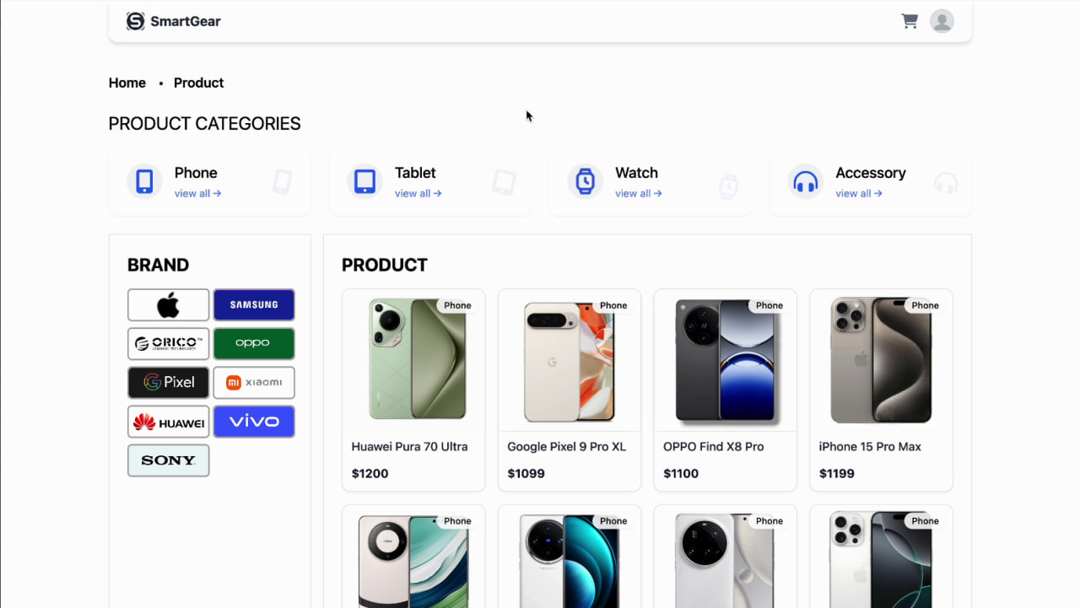Figure 6: Product Page*

**Figure 6: Product Page User Interface**

This report details the design and functionalities of the product page within the SmartGear user interface, based on the provided image and your specifications. This page is designed to offer comprehensive product exploration and facilitate the purchasing process.

The persistent header, consistent with the home page, features the "SmartGear" logo on the left, reinforcing brand identity. On the right, the shopping cart and user profile icons remain accessible, allowing for continuous navigation to crucial e-commerce functions.

The core of the product page focuses on presenting a list of products. Each product is displayed within its own dedicated section or card, typically featuring a clear image of the item. This visual presentation aids in quick identification and browsing.

A key feature of this product page is its robust filtering system, designed to help users efficiently locate specific items. Users have the ability to filter products by both "Brand" and "Category," or a combination of both, providing a highly refined search experience. This advanced filtering capability allows users to narrow down extensive product lists based on their precise preferences.

For each product displayed, users are presented with two primary interaction options. Firstly, they can directly add the product to their shopping cart. This "Add to Cart" functionality is strategically placed for immediate action, streamlining the purchasing journey. Secondly, users can click on a product to "View Detail," which navigates them to a dedicated product detail page. This page is expected to provide comprehensive information about the selected product, including detailed specifications, multiple high-resolution images, customer reviews, and potentially related items, enabling users to make informed purchasing decisions.

The overall layout and functionality of the product page are designed to enhance user experience by providing clear navigation, powerful filtering options, and straightforward paths to purchase or deeper product exploration.

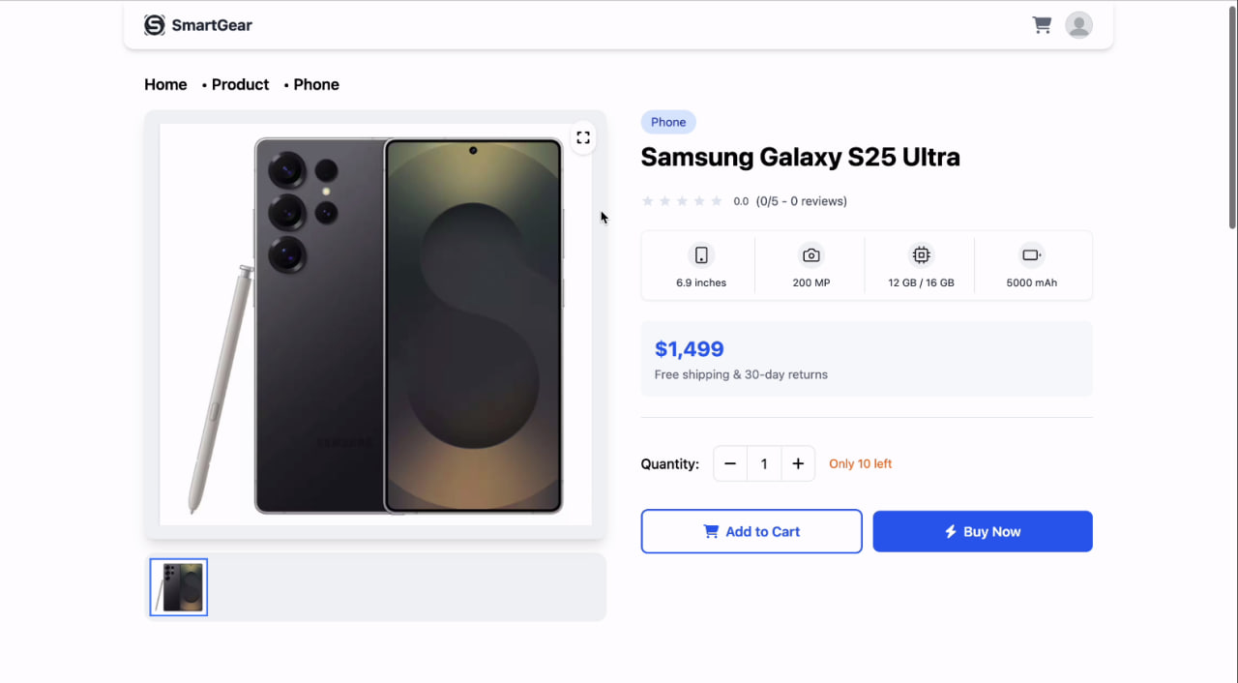

*Figure 7: Product detail Part(1)*

**Figure 7: Product Detail Part (1)**

Figure 7 showcases the upper section of the product detail page, focusing on key product identification, pricing, and initial interaction points.

The page maintains the consistent header with the "SmartGear" logo on the left and the shopping cart and user profile icons on the right, ensuring a familiar navigation experience. A breadcrumb navigation trail, "Home > Product > Phone," is present below the header, indicating the user's current location within the site hierarchy.

The main content area is split into two primary columns:

* **Product Visuals (Left Column):** A large, high-quality image of the featured product, the "Samsung Galaxy S25 Ultra," is prominently displayed. A small expand icon in the top right of the image suggests functionality to view the image in full screen or a larger modal. Below the main image, a smaller thumbnail is visible, indicating the presence of multiple product images that the user can browse.
* **Product Overview & Call to Action (Right Column):**
  + **Category Tag:** A small "Phone" tag categorizes the product.
  + **Product Name:** "Samsung Galaxy S25 Ultra" is clearly displayed as the product title.
  + **Customer Rating:** A star rating system, currently showing "0.0 (0/5 - 0 reviews)," provides a visual indicator for user feedback and potential reviews.
  + **Key Specifications:** Icons and values highlight crucial product attributes at a glance: "6.9 inches" (screen size), "200 MP" (camera resolution), "12 GB / 16 GB" (RAM/storage options), and "5000 mAh" (battery capacity).
  + **Price and Delivery Information:** The price, "$1,499," is boldly presented, accompanied by reassuring notes like "Free shipping & 30-day returns."
  + **Quantity Selector:** An interactive component allows users to adjust the desired quantity using "-" and "+" buttons. The current quantity is displayed centrally. A "Only 10 left" message creates a sense of urgency.
  + **Action Buttons:** Two prominent call-to-action buttons are available: "Add to Cart" (likely for continued shopping) and "Buy Now" (for immediate purchase and checkout).

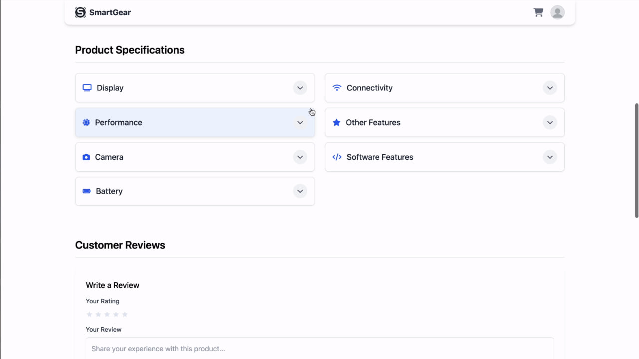

*Figure 8: Product detail Page(2)*

**Figure 8: Product Detail Page (2)**

Figure 8 displays the lower section of the product detail page, providing more in-depth information and avenues for user feedback.

* **Product Specifications:** This section is structured using expandable accordion panels, allowing users to delve into specific technical details without overwhelming the initial view. Categories include:
  + "Display"
  + "Connectivity"
  + "Performance"
  + "Other Features"
  + "Camera"
  + "Software Features"
  + "Battery" Each panel has a dropdown arrow, indicating that clicking on it will reveal further detailed specifications.
* **Customer Reviews:** This dedicated section allows users to engage with the product by providing feedback.
  + "Write a Review" prompt encourages new reviews.
  + A star rating input enables users to assign a rating to the product.
  + A text area labeled "Your Review" provides space for users to "Share your experience with this product...".

The product detail page, as presented across both figures, is designed to be comprehensive, providing both high-level summaries and granular details, along with clear calls to action and opportunities for user interaction and feedback.

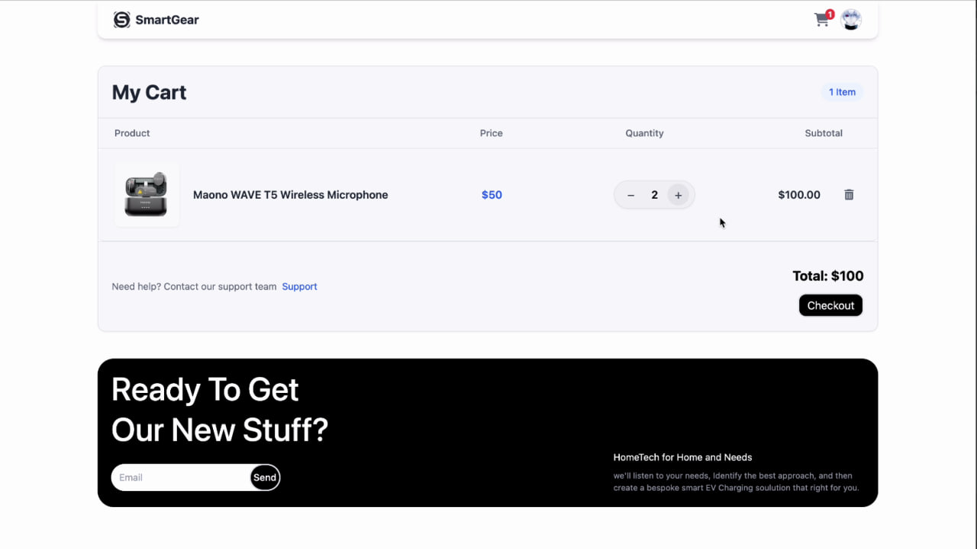

*Figure 9: Cart Page*

**Figure 9: Cart Page User Interface**

This report outlines the design and functionalities of the cart page within the SmartGear user interface, based on the provided image. This page is designed to allow users to review their selected products before proceeding to checkout.

The page prominently features the "SmartGear" logo in the header, maintaining consistent branding with other pages of the interface. On the right side of the header, icons for the shopping cart (with a notification indicating items) and user profile are present, ensuring easy navigation to these key e-commerce features.

The main section of the page is titled "My Cart," clearly indicating its purpose. A sub-heading indicates the number of items currently in the cart, providing a quick summary to the user.

The core of the cart page is a well-structured table that displays the items added by the user. The columns are clearly labeled as "Product," "Price," "Quantity," and "Subtotal," making it easy for users to understand the details of each item.

Each row in the cart represents a distinct product. For each product, the following information is presented:

* **Product Image:** A small, clear image of the product (e.g., "Maono WAVE T5 Wireless Microphone").
* **Product Name:** The full name of the product.
* **Price:** The individual price of the product.
* **Quantity Selector:** An interactive element with "-" and "+" buttons allowing users to easily adjust the quantity of each item. The current quantity is displayed between these buttons.
* **Subtotal:** The calculated subtotal for that specific product based on its price and selected quantity.
* **Remove Item:** A trash bin icon is present, enabling users to easily remove an item from their cart.

Below the list of cart items, a small text prompt "Need help? Contact our support team" with a "Support" link indicates available customer service. This provides reassurance and a point of contact for users who might encounter issues.

At the bottom right of the cart summary, the "Total: $100" clearly displays the cumulative cost of all items in the cart. A prominent "Checkout" button is positioned directly below the total, serving as the primary call to action to proceed with the purchase.

The overall design of the cart page is clean, organized, and user-friendly, providing all necessary information and functionalities for users to manage their selections and move forward with their purchase.

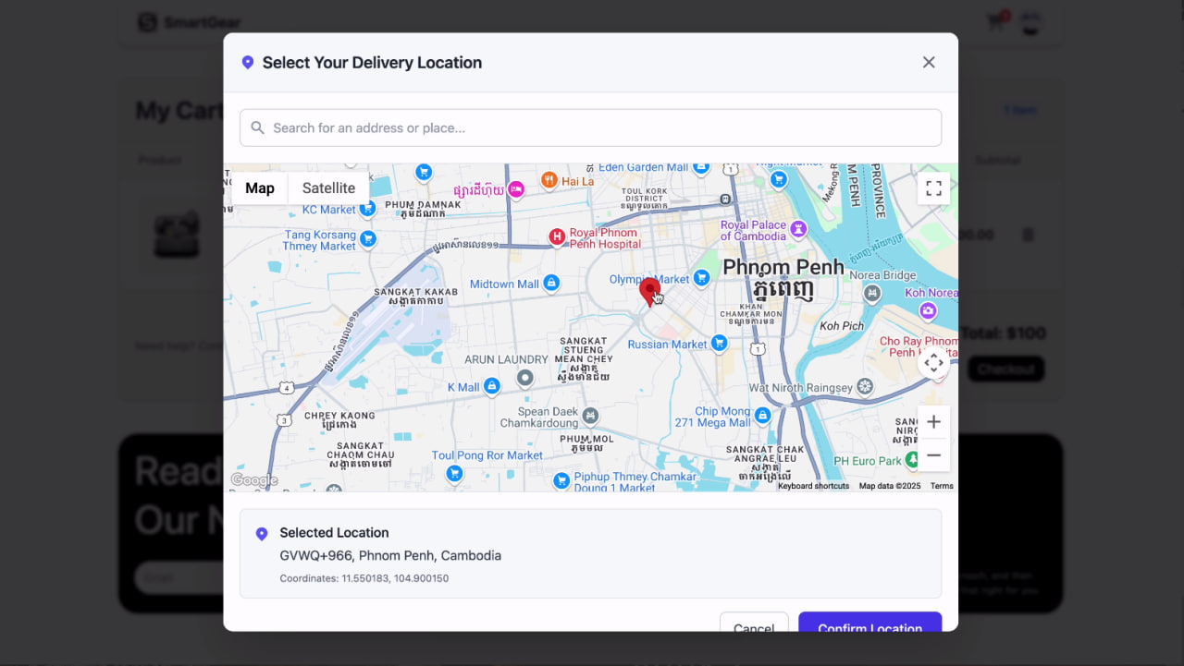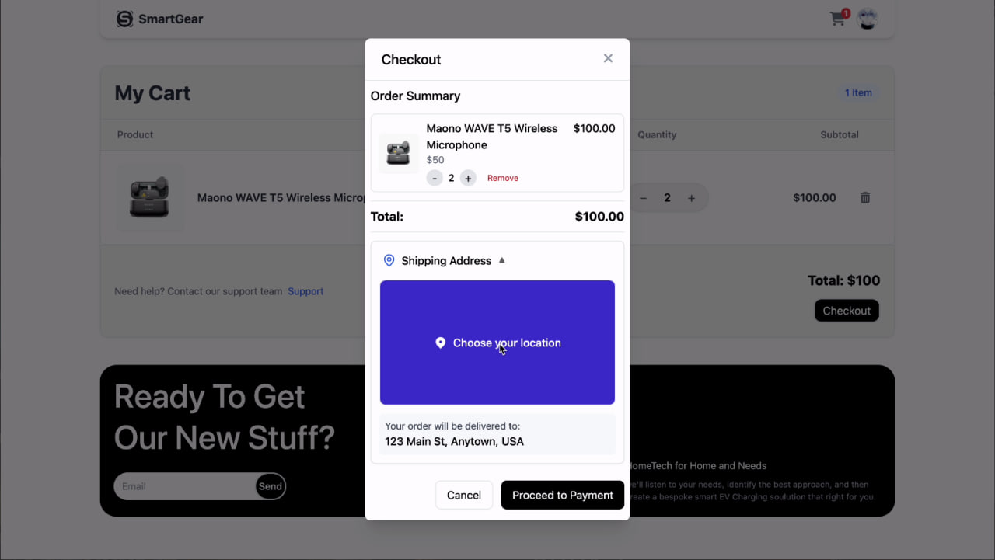

Figure 10: Checkout card. Figure 11: Choose Location for delivery

**Checkout and Location Selection User Interface Report**

This report details the user interface for the checkout process and location selection, as depicted in Figure 10 and Figure 11. These interfaces are crucial steps in finalizing a user's purchase within the SmartGear application (11, 12, 13).

**Figure 10: Checkout Card**

Figure 10 presents a "Checkout" card, which appears to be a modal or pop-up interface guiding the user through the final stages of their order.

At the top of this card, an "Order Summary" section provides a concise overview of the items the user is about to purchase. For each product, it displays:

* The product name (e.g., "Maono WAVE T5 Wireless Microphone").
* The individual price of the product.
* The quantity selected for that product.
* An option to "Remove" the item, allowing for last-minute adjustments.

Below the individual product summaries, a "Total: $100.00" clearly states the overall cost of the order, ensuring transparency for the user.

A significant section titled "Shipping Address" is present, indicating that the user needs to provide or confirm their delivery details. Within this section, a prominent button or area labeled "Choose your location" with a map pin icon suggests that the user will be able to select their delivery address, likely through an interactive map interface.

At the bottom of the "Checkout" card, two action buttons are provided: "Cancel" and "Proceed to Payment." The "Cancel" button allows users to exit the checkout process, while "Proceed to Payment" moves them to the next step, presumably for payment processing. A confirmation message, "Your order will be delivered to: 123 Main St, Anytown, USA," gives immediate feedback on the selected address.

**Figure 11: Choose Location for Delivery**

Figure 11 displays a "Select Your Delivery Location" interface, which is activated when the user interacts with the "Choose your location" option from the checkout card. This interface is likely another modal or full-screen view focused on geographic selection.

At the top of this interface, a search bar labeled "Search for an address or place..." allows users to input their desired delivery location directly.

The central and most prominent part of this interface is an interactive map. This map provides a visual representation of geographical areas, enabling users to pinpoint their exact delivery spot. It includes typical map controls such as zoom in/out and potentially switching between "Map" and "Satellite" views. A red map marker appears to indicate a selected point on the map, likely the proposed delivery location.

At the bottom of the map, a "Selected Location" area displays the precise address details (e.g., "GVWO+96J, Phnom Penh, Cambodia") and geographical coordinates (e.g., "Coordinates: 11.5500183, 104.900150") of the chosen delivery point. This provides clear confirmation of the selected address.

Finally, a "Confirm location" button is available, allowing the user to finalize their selection and return to the checkout process with the updated delivery address. A "Cancel" button offers the option to discard the location selection.Both figures demonstrate a well-structured and user-friendly approach to completing an order, from reviewing items to confirming the delivery address.

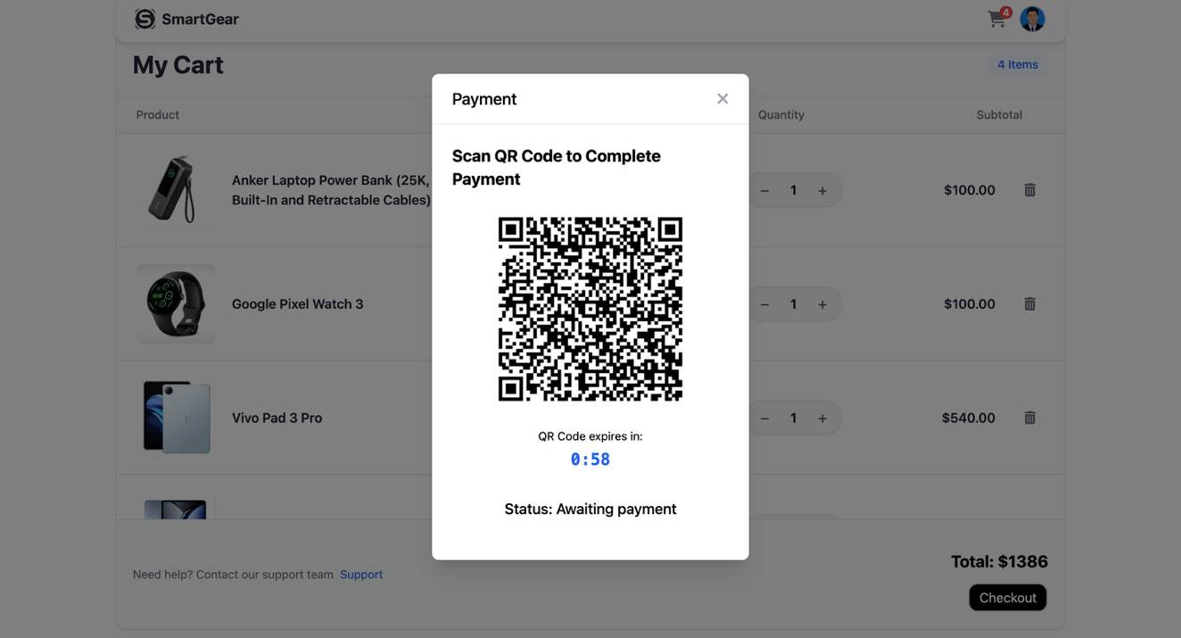

*Figure 12: QR code for payment*

**Figure 12: QR Code for Payment**

Figure 12 displays a "Payment" modal, overlaid on what appears to be the "My Cart" page. This modal is designed to enable users to complete their payment by scanning a QR code.

At the top of the modal, the title "Payment" is clearly visible, along with an 'X' icon, allowing the user to close the modal if they wish to cancel the payment process or return to the cart.

The primary instruction within the modal is "Scan QR Code to Complete Payment," which is prominently displayed to guide the user.

Below the instruction, a large, centrally located QR code is presented. This QR code is the core element of this payment method, which users are expected to scan using a mobile banking application or a dedicated payment app on their smartphone.

Beneath the QR code, a countdown timer, "QR Code expires in: 0:58," indicates the limited time available for the user to complete the scan and payment. This creates a sense of urgency and ensures a timely transaction.

Finally, a "Status: Awaiting payment" message provides real-time feedback to the user on the current state of the transaction, indicating that the system is waiting for the payment to be processed through the QR code scan.

The overall design of this payment interface is straightforward and focused, providing all the necessary information and a clear mechanism for users to finalize their purchase through a QR code scan.

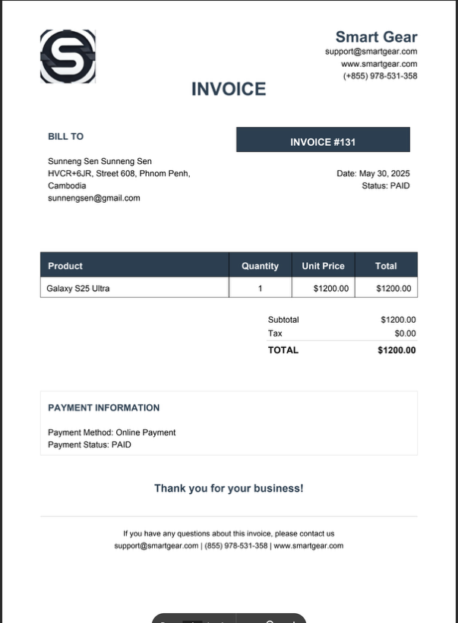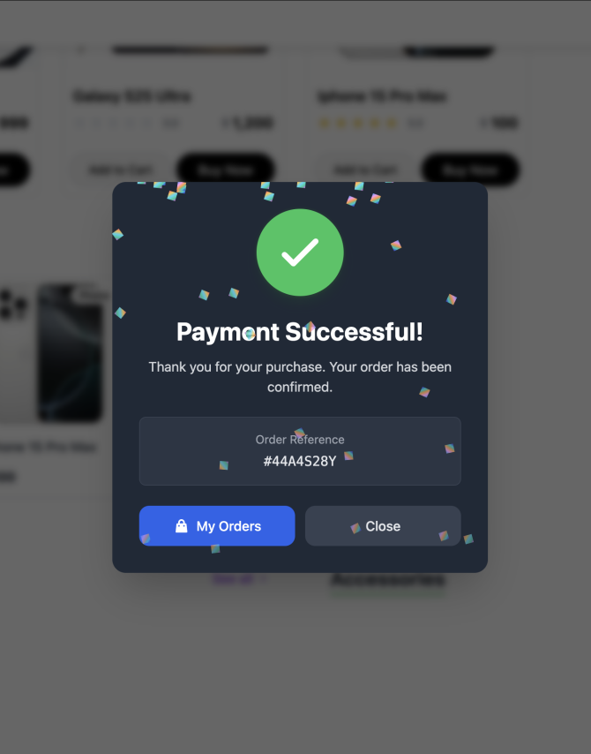

Figure 13: Payment Successful Figure 14: Invoice

**Figure 13: Payment Successful**

Figure 13 displays a "Payment Successful!" modal or pop-up. This interface appears immediately after a successful payment transaction, providing confirmation to the user.

At the top of the modal, a large green checkmark icon visually confirms the success of the payment, which is then reinforced by the bold text "Payment Successful!".

A friendly message, "Thank you for your purchase. Your order has been confirmed," reassures the user that their transaction was processed correctly and their order is in motion.

An "Order Reference" number, "#44A4528Y," is clearly displayed. This unique identifier is important for users to track their order or for any future customer service inquiries.

At the bottom of the modal, two action buttons are provided: "My Orders" and "Close." The "My Orders" button allows the user to navigate directly to their order history or tracking page, while the "Close" button dismisses the modal and likely returns the user to the previous page (e.g., the home page or product page).

The design of this modal is clean, direct, and reassuring, effectively communicating the success of the payment and guiding the user to next steps.

**Figure 14: Invoice**

Figure 14 presents a digital "INVOICE" document, which serves as a formal record of the user's purchase.

The invoice prominently features the "Smart Gear" logo at the top left, along with contact information including a website, email, and phone number, for any support needs. The document is clearly titled "INVOICE".

On the right side of the invoice header, an "INVOICE #131" provides a unique identifier for this specific transaction. Details such as "Date: May 26, 2025" and "Status: PAID" confirm the transaction's specifics.

A "BILL TO" section clearly outlines the recipient's details, including their name, address, and email (e.g., "Sunmeng Sen Sunmeng Sen," "HVCR+3J8, Street 608, Phnom Penh, Cambodia," "sunmengsen@gmail.com").

The core of the invoice is a table-like structure detailing the purchased products. It includes columns for "Product," "Quantity," "Unit Price," and "Total." In this example, "Galaxy S25 Ultra" is listed with a quantity of "1," a unit price of "$1200.00," and a total of "$1200.00.". Below the product details, a summary of charges includes:

* "Subtotal: $1200.00"
* "Tax: $0.00"
* "Shipping: $0.00"
* A bold "TOTAL: $1200.00," representing the final amount paid.

A "PAYMENT INFORMATION" section specifies the "Payment Method: Online Payment" and "Payment Status: PAID," reinforcing the completion of the transaction.

A "Thank you for your business!" message offers a polite closing.

Finally, a section for inquiries provides contact details for support if the user has any questions about the invoice.

This invoice document is comprehensive, professional, and provides all necessary information for record-keeping and customer confidence.

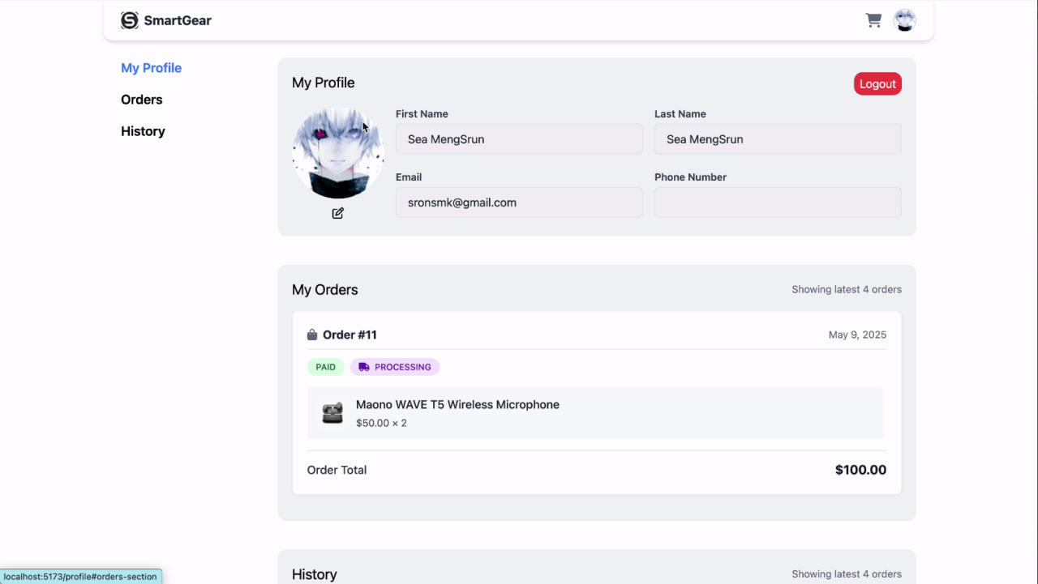

*Figure 15: Profile Page*

**Figure 15: Profile Page**

Figure 15 displays the user's "Profile Page," which is designed to provide a comprehensive overview of their account details and past activities.

The page maintains the consistent header with the "SmartGear" logo on the left and the shopping cart and user profile icons on the right, ensuring a familiar navigation experience.

On the left side of the profile page, a navigation sidebar is present, offering quick access to different sections of the user's profile:

* "My Profile": This is the currently selected section, indicating the user is viewing their personal details.
* "Orders": This link would likely lead to a detailed view of active or pending orders.
* "History": This link would probably display a complete history of past purchases.

The main content area of the profile page is structured into several distinct sections. The top section, clearly labeled "My Profile," displays the user's personal information. This includes:

* User Avatar: A circular image representing the user.
* First Name and Last Name: "Sea MengSrun" is displayed for both, indicating the user's full name. These fields appear editable, suggesting users can update their details.
* Email: "srsrsmk@gmail.com" is shown, likely also editable.
* Phone Number: A placeholder is available for the phone number.
* Edit Icon: A small edit icon next to the email suggests that these personal details can be modified by the user.
* Logout Button: A prominent "Logout" button is strategically placed at the top right of this section, allowing users to securely sign out of their account.

Below the "My Profile" section, an "My Orders" section provides a summary of recent orders. It indicates "Showing latest 4 orders," suggesting pagination or a limited view. An example order, "Order #11" from "May 9, 2025," is displayed with its status ("PAID" and "PROCESSING"). Details of the product within the order (e.g., "Maono WAVE T5 Wireless Microphone, $50.00 x 2") and the "Order Total: $100.00" are also visible. This section allows users to quickly check the status of their ongoing purchases.

Finally, a "History" section is present at the bottom, also indicating "Showing latest 4 orders." This section would presumably list completed orders, allowing users to review their past purchases.

The overall design of the profile page is intuitive and user-centric, providing easy access to personal data and order information.

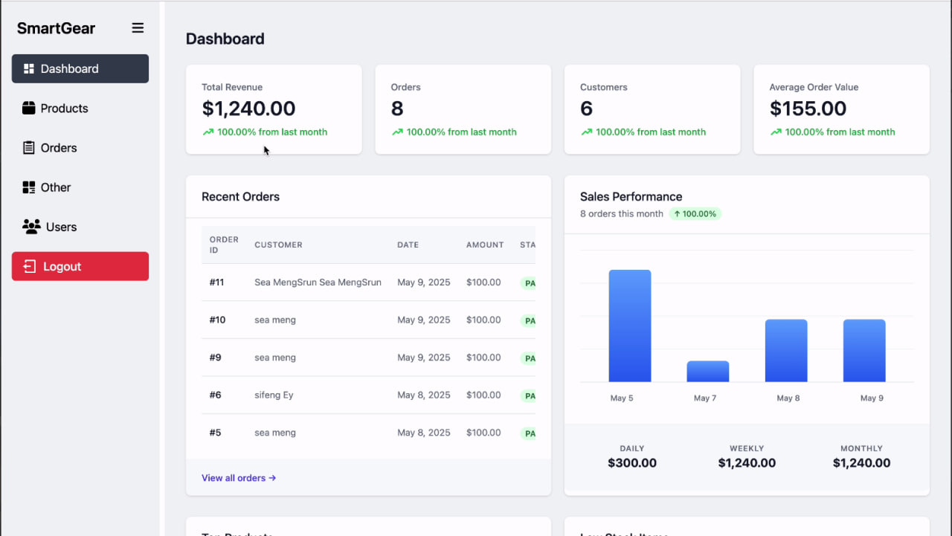

*Figure 16: Hone Page for Admin dashboard*

**Figure 15 Admin Dashboard Overview**

The Admin Dashboard provides a centralized hub for managing the e-commerce operations.

The consistent "SmartGear" logo is visible at the top left, maintaining branding. A clear sidebar navigation on the left allows administrators to switch between different management sections:

* Dashboard: This is the current view, providing an executive summary of key metrics.
* Products: Likely for managing product listings, inventory, and details.
* Orders: For detailed order processing and fulfillment.
* Other: Potentially for miscellaneous settings or features.
* Users: For managing customer accounts and user profiles.
* Logout: A prominent "Logout" button is available for secure session termination.

The main content area of the dashboard is structured with several key performance indicator (KPI) cards at the top, offering immediate insights into business health:

* Total Revenue: "$1,240.00" is displayed, with a percentage indicating performance "100.00% from last month."
* Orders: "8" orders are shown, also with a "100.00% from last month" comparison.
* Customers: "6" customers are listed, again with a "100.00% from last month" comparison.
* Average Order Value: "$155.00" is displayed.

Below these KPIs, the dashboard is further divided into sections providing more granular data.

**Recent Orders**

This section provides a quick view of the latest transactions, including:

* Order ID: A unique identifier for each order (e.g., "#11," "#10").
* Customer: The name of the customer who placed the order.
* Date: The date the order was placed (e.g., "May 9, 2025").
* Amount: The total value of the order.
* Status (STA): The current status of the order (e.g., "PA," likely indicating "Paid" or "Pending Action"). A "View all orders" link allows administrators to access a more comprehensive order management page.

**Sales Performance**

This section visually represents sales data, likely over a period of time, using a bar chart. The bar chart shows "8 orders this month" with a "100.00%" increase. Below the chart, aggregated sales figures are provided:

* DAILY: "$300.00"
* WEEKLY: "$1,240.00"
* MONTHLY: "$1,240.00"

This provides a quick overview of sales trends and performance over different timeframes.

**Top Products**

This panel lists products that are performing well, indicating their sales volume. For each product, it shows:

* A small image of the product.
* The product name (e.g., "Anker Laptop Power Bank," "Google Pixel Watch 3").
* The product category (e.g., "Accessory," "Watch," "Phone").
* The total sales figure (e.g., "$100.00") and the number of units sold (e.g., "6 sold"). A "View all products" link directs to the full product catalog.

**Low Stock Items**

This critical inventory management panel highlights products that are running low on stock, enabling timely restocking actions. For each item, it displays:

* A small image of the product.
* The product name (e.g., "Sony Xperia 1 VI," "Xiaomi 15 Ultra").
* The product type (e.g., "Phone," "Accessory").
* The current quantity "in stock" (e.g., "55 in stock," "74 in stock").
* A "Restock" button, providing a direct action to replenish inventory. A "View Inventory" link allows administrators to access a detailed inventory management page.

The Admin Dashboard is designed to be a comprehensive and actionable tool, providing administrators with the necessary data and quick access to manage their e-commerce business effectively.

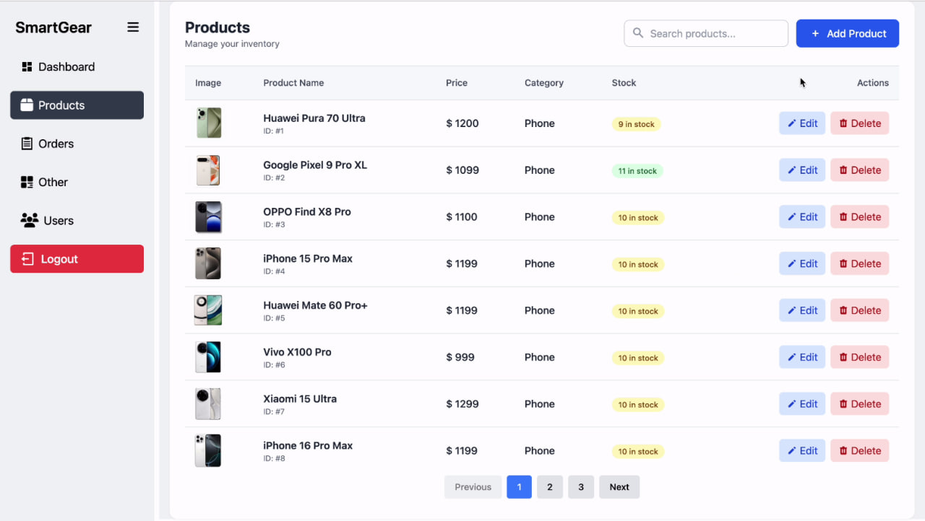

*Figure 17: Manage Product Page*

**Figure 17: Manage Product Page**

Figure 17 displays the "Manage Product Page," which allows administrators to control their product inventory. The page features a consistent "SmartGear" logo and a familiar sidebar navigation on the left, offering quick access to "Dashboard," "Products" (currently selected), "Orders," "Other," and "Users," along with a "Logout" option. The main content area of the "Manage Product" section is structured as follows:

* Header: "Products" is displayed, with a sub-heading "Manage your inventory."
* Search Bar: A "Search products..." bar is available at the top right, allowing administrators to quickly find specific products.
* Add Product Button: A prominent "+ Add Product" button provides a direct call to action for adding new items to the inventory.
* Product Table: The core of the page is a table listing all products, with clear column headers: "Image," "Product Name," "Price," "Category," "Stock," and "Actions."
* Image: A small thumbnail of each product is shown.
* Product Name: The full name of the product (e.g., "Huawei Pura 70 Ultra," "Google Pixel 9 Pro XL").
* Price: The selling price of the product.
* Category: The category to which the product belongs (e.g., "Phone").
* Stock: The current quantity of the product in stock, with a clear visual indicator (e.g., "9 in stock," "10 in stock").
* Actions: For each product, "Edit" and "Delete" buttons are provided, enabling administrators to modify product details or remove items from the inventory.
* Pagination: At the bottom of the table, pagination controls (e.g., "Previous," "1," "2," "3," "Next") are available to navigate through extensive product lists.

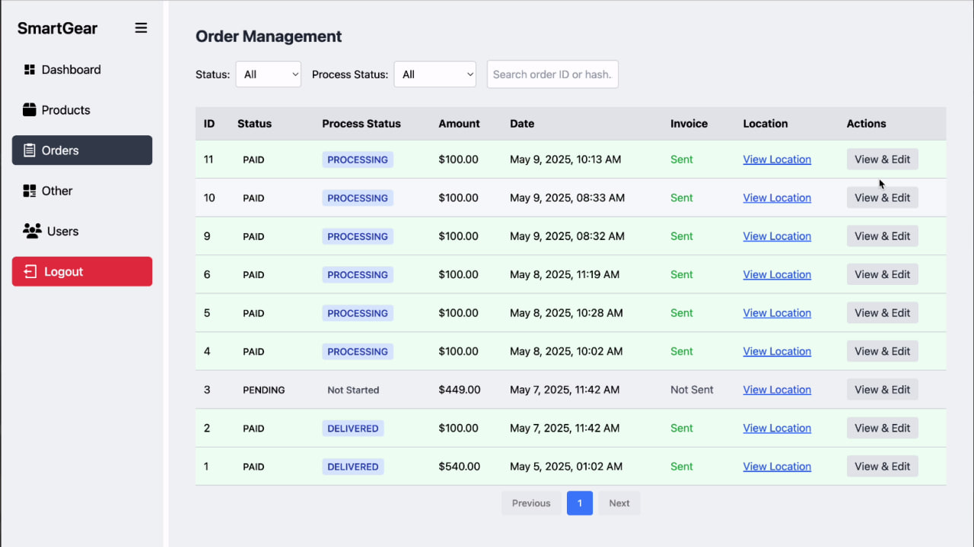

*Figure 18: Manage order Page*

**Figure 18: Manage Order Page**

Figure 18 displays the "Manage Order Page," designed for administrators to oversee and process customer orders. This page also maintains the consistent "SmartGear" branding and the left-hand sidebar navigation, with "Orders" being the selected section.The main content area of the "Order Management" section is structured as follows:

* Header: "Order Management" is displayed.
* Status Filters: Dropdown menus for "Status: All" and "Process Status: All" allow administrators to filter orders based on their overall status (e.g., Paid, Pending) and their processing stage.
* Search Bar: A "Search order ID or hash" bar facilitates searching for specific orders.
* Order Table: The primary display is a table listing all orders, with the following columns: "ID," "Status," "Process Status," "Amount," "Date," "Invoice," "Location," and "Actions."
  + **ID:** The unique identifier for each order.
  + **Status:** The payment status of the order (e.g., "PAID," "PENDING").
  + **Process Status:** The current stage of order fulfillment (e.g., "PROCESSING," "DELIVERED," "Not Started").
  + **Amount:** The total value of the order.
  + **Date:** The date and time the order was placed.
  + **Invoice:** A "Sent" indicator and a "View Invoice" link, allowing administrators to view the detailed invoice for the order.
  + **Location:** A "View Location" link, likely opening a map or address detail for the delivery.
  + **Actions:** "View & Edit" buttons are provided, enabling administrators to view detailed order information and make necessary edits or updates to the order's status.
* Pagination: Similar to the product page, pagination controls (e.g., "Previous," "1," "Next") are present for navigating through order lists.

Both pages provide administrators with essential tools for managing the e-commerce platform's core operations efficiently.

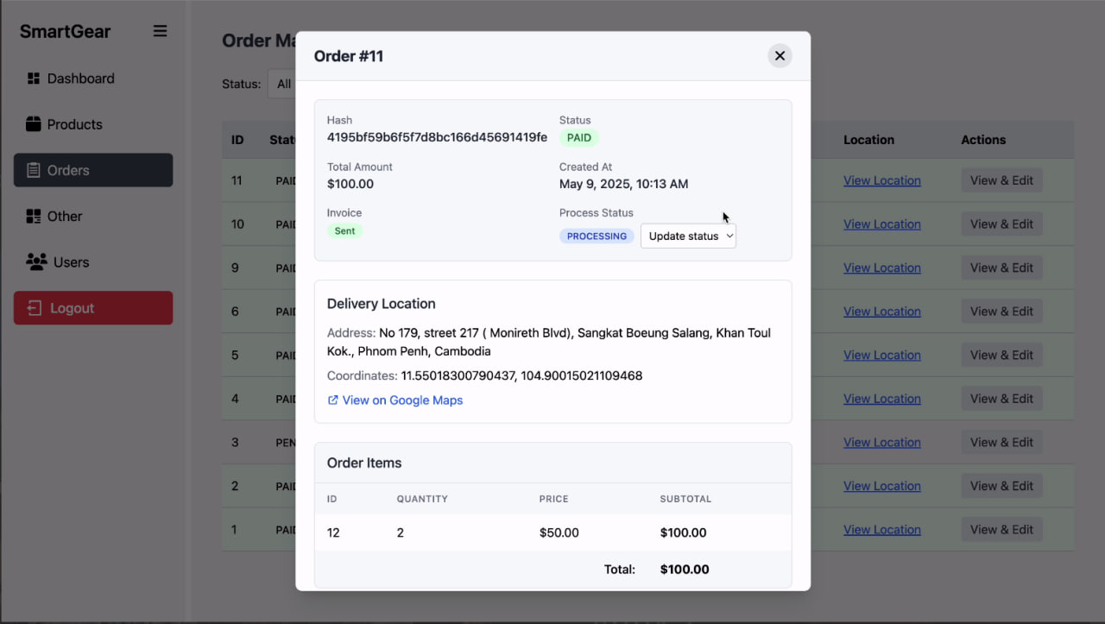

*Figure 19: Order detail*

**Figure 19: Order Detail**

Figure 19 displays a modal or pop-up interface titled "Order #11," providing a comprehensive view of a specific customer order. This interface is accessed by an seller from the "Manage Order Page" (as described in the previous report) by clicking a "View & Edit" action. The order detail modal is structured into several key sections:

* **Order Summary:**
  + **Hash:** A unique alphanumeric identifier for the order (e.g., "419bfbfb9f7d8fbc166d45691419fe").
  + **Status:** The payment status, clearly marked as "PAID."
  + **Total Amount:** "$100.00" indicates the total value of the order.
  + **Created At:** The date and time the order was placed (e.g., "May 9, 2025, 10:13 AM").
  + **Invoice:** An "Invoice" link or indicator, potentially allowing the administrator to view or resend the invoice.
  + **Process Status:** This section is crucial for manual updates. It displays the current process status (e.g., "PROCESSING") and includes an "Update status" button or dropdown. This strongly suggests that administrators can manually change the delivery or processing status of the order.
* **Delivery Location:**
  + Detailed address information is provided (e.g., "Address: No 179, street 217 (Moniveth Blvd), Sangkat Boeung Salang, Khan Toul Kok, Phnom Penh, Cambodia").
  + Geographical coordinates are also listed (e.g., "Coordinates: 11.55016300790437, 104.90015021109468").
  + A "View on Google Maps" link is present, allowing the administrator to quickly view the delivery location on a map for verification or navigation purposes.
* **Order Items:**
  + A table-like section lists the products included in the order with columns for "ID," "QUANTITY," "PRICE," and "SUBTOTAL."
  + In the example, an item with "ID 12" has a "QUANTITY" of "2," a "PRICE" of "$50.00," and a "SUBTOTAL" of "$100.00."
  + A "Total: $100.00" is displayed at the bottom of the order items, confirming the total value of the products.

The "Order Detail" modal provides administrators with all the necessary information to understand an order comprehensively and the critical functionality to manually update its processing and delivery status, which is essential for effective order management.

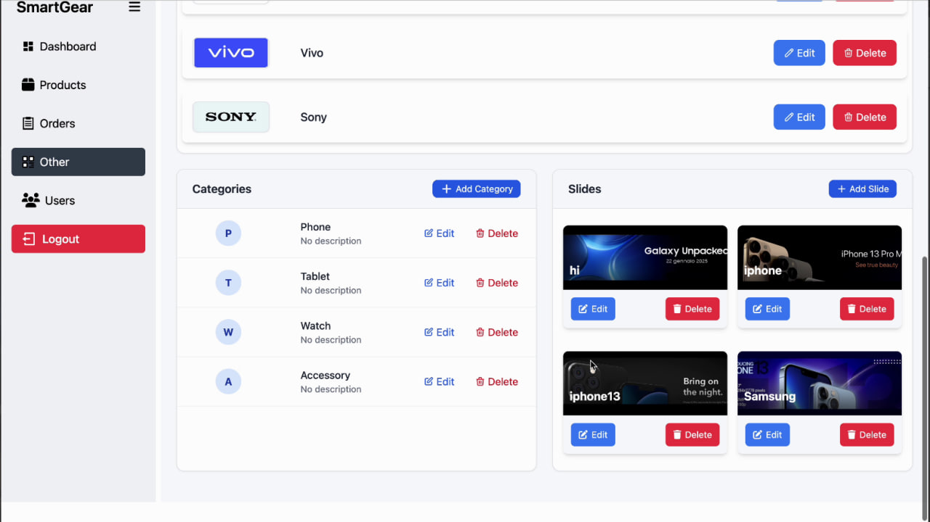

*Figure 20: Control brand, slide and categories*

**Figure 20: Control brand, slide and categories**

Figure 20 displays an administrative panel, likely accessed through the "Other" section of the sidebar navigation. This page offers functionalities for Create, Read, Update, and Delete (CRUD) operations for various content types.

The page maintains the consistent "SmartGear" branding in the top left and features the familiar sidebar navigation on the left, with "Other" being the selected section. This sidebar provides access to "Dashboard," "Products," "Orders," "Other," and "Users," along with a "Logout" option. The main content area of this control panel is divided into three distinct sections:

**Brand Management**

This section is dedicated to managing product brands.

* A "+ Add Brand" button allows administrators to create new product categories
* Each brand is displayed with its logo (e.g., "vivo," "SONY") and name.
* For each brand, "Edit" and "Delete" buttons are provided, allowing administrators to modify brand details or remove brands from the system.
* An "Add Brand" button is likely present (though not explicitly visible in this cropped view) to introduce new brands.

**Categories Management**

This section handles the management of product categories.

* A prominent "+ Add Category" button allows administrators to create new product categories.
* Each category is listed with a circular icon (e.g., "P" for Phone, "T" for Tablet, "W" for Watch, "A" for Accessory), its name (e.g., "Phone," "Tablet"), and a brief "No description" placeholder, suggesting that descriptions can be added.
* For each category, "Edit" and "Delete" buttons are available, enabling modification of category details or removal of categories.

**Slides Management**

This section is designed for managing the promotional slides, likely displayed on the home page banners.

* A "+ Add Slide" button allows administrators to upload or create new promotional slides.
* Each slide is displayed with a thumbnail image, showcasing the visual content of the slide (e.g., "Galaxy Unpacked," "iPhone 13 Pro Max").
* For each slide, "Edit" and "Delete" buttons are provided, allowing administrators to modify slide content or remove them from the rotation.

The "Control brand, slide and Categories" page provides a comprehensive and organized interface for administrators to manage key content elements that directly impact the user-facing e-commerce experience.

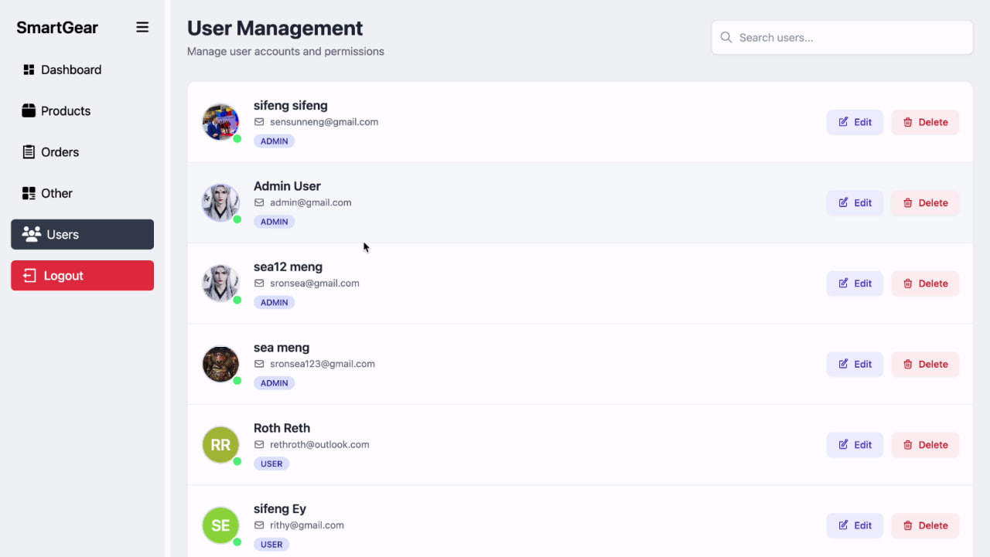

*Figure 21: Manage user Page*

**Figure 21: Manage User Page**

Figure 21 displays the "User Management" page, accessible through the "Users" section of the sidebar navigation. This page allows administrators to manage user accounts and assign permissions.

The page maintains the consistent "SmartGear" branding in the top left and features the familiar sidebar navigation on the left, with "Users" being the selected section. This sidebar provides access to "Dashboard," "Products," "Orders," "Other," and "Users," along with a "Logout" option. The main content area of the "User Management" section is structured as follows:

* **Header:** "User Management" is displayed, with a sub-heading "Manage user accounts and permissions."
* **Search Bar:** A "Search users..." bar is available at the top right, allowing administrators to quickly find specific users.
* **User List:** The core of the page is a list of user accounts, each entry displaying:
  + **User Avatar:** A small profile picture or initial for the user.
  + **User Name:** The name of the user (e.g., "silfeng silfeng," "Admin User," "sea12 meng," "sea meng," "Roth Reth," "silfeng Ey").
  + **Email:** The email address associated with the user's account.
  + **User Role:** A tag indicating the user's role (e.g., "ADMIN," "USER"). This clearly differentiates administrative accounts from regular user accounts.
  + **Actions:**For each user, "Edit" and "Delete" buttons are provided, enabling administrators to modify user details or remove accounts from the system.

The "User Management Page" provides a clear and organized interface for administrators to effectively oversee and control user access and permissions within the SmartGear system.

## 4.3 Performance Evaluation

The application was evaluated for performance based on the following metrics:

* Response Time**:** API endpoints typically responded within 150-300 milliseconds under normal load, ensuring a responsive user experience.
* Load Testing**:** The backend was tested with 20 concurrent users. The system handled transactions effectively, with minimal latency observed.
* QR Code Generation Time**:** The QR codes for payment were generated instantly upon request, typically within 50ms.
* Email Delivery Time**:** Invoices were successfully delivered to the user’s email within 2–5 seconds post-checkout.

These results demonstrate the system’s efficiency and scalability for small to medium e-commerce operations .

## 4.4 Summary of Results

The developed E-Store system met all functional and non-functional requirements. It successfully integrated various modern technologies to provide a full-featured e-commerce experience. The frontend was interactive and responsive, while the backend was secure and efficient. Performance testing confirmed the reliability of the system under concurrent usage. Additionally, advanced features such as KHQR payment and PDF invoice generation added significant value and practicality to the solution.

# CAHPTER 5

**DISCUSSION**

## 5.1 Interpretation of Results

The results presented in Chapter 4 demonstrate that the e-store system developed using Spring Boot and Vue.js successfully fulfills its intended objectives. Each core functionality was implemented effectively, including user authentication, product management, QR code payment integration, and invoice generation. The system’s ability to deliver a secure and responsive user experience highlights the benefits of using a modern tech stack.

The performance tests indicate that the backend handles multiple concurrent users efficiently and the frontend maintains interactivity and usability. The integration of Bakong KHQR payment via QR code scanning worked seamlessly, enhancing transaction convenience for local users in Cambodia **(National Bank of Cambodia, n.d.).** Furthermore, the automated email system ensures users receive order confirmations and invoices promptly, reinforcing trust in the system.

Overall, the system aligns with user expectations in terms of usability, functionality, and reliability.

## 5.2 Challenges Faced During Development

During the development of the system, several technical and non-technical challenges were encountered:

* **QR Code Payment Integration**: Implementing the KHQR payment system required in-depth understanding of the Bakong API and secure MD5 signature generation. Properly generating the deep link and rendering the QR code dynamically on the frontend was a key technical hurdle**.**
* **JWT and OAuth2 Authentication**: Balancing both custom JWT-based login and Google OAuth login demanded careful configuration of Spring Security filters and token handling mechanisms.
* **Email Sending with Attachments:** Generating PDF invoices dynamically and sending them through email with appropriate formatting and encoding was time-consuming due to MIME type handling and iTextPDF configurations.
* **Frontend-State Management**: Managing global state using Pinia and syncing it with backend responses took time to optimize, especially with cart updates and user session handling.
* **Testing Across Devices:** Ensuring full responsiveness and proper layout rendering on various screen sizes required continuous testing and Tailwind CSS adjustments.
* **Time Constraints**: As with many software projects, balancing feature implementation with deadlines posed scheduling challenges.

Despite these obstacles, all critical functionalities were successfully delivered, and the system was optimized through iterative testing and improvements.

## 5.3 Comparison with Existing Systems

Compared to existing e-store platforms, the developed system offers several unique and competitive advantages:

|  |  |  |
| --- | --- | --- |
| Feature | Existing Platforms | Developed System |
| Payment Method | Typically support PayPal, credit cards | |  | | --- | |  |  |  | | --- | | KHQR via Bakong – tailored to Cambodian users | |
| Customization | Limited in hosted solutions | |  | | --- | |  |  |  | | --- | | Full codebase access for complete customization | |
| Authentication | |  | | --- | |  |  |  | | --- | | Standard email/password | | |  | | --- | |  |  |  | | --- | | JWT + Google OAuth2 | |
| Invoice Generation | |  | | --- | | Often requires plugin | | Built-in PDF invoice generation with email |
| Local Integration | Not focused on Cambodia-specific services | Designed specifically for Cambodian market |
| Tech Stack | Varies, often monolithic or plugin-based | Modern microservices architecture (Spring Boot + Vue.js) |

*Table 2: Comparison with Existing Systems*

This table, Table 2: Comparison with Existing Systems, serves to articulate the unique value proposition and competitive advantages of the developed E-Store system by directly contrasting its features and underlying technologies with those commonly found in existing e-commerce platforms. This comparison highlights how the developed system addresses specific market needs and leverages modern development practices.The table is structured into three main columns:

* **Feature**: This column lists the key aspects or functionalities being compared across different e-commerce solutions.
* **Existing Platforms**: This column describes the typical characteristics or approaches observed in traditional or readily available e-commerce platforms, particularly those that may not be specifically tailored for the Cambodian context or small to medium-sized businesses.
* **Developed System**: This column outlines how the project's E-Store system implements the respective feature, emphasizing its specific design choices, technologies, and localized adaptations, often referring to supporting citations.

**Detailed Breakdown of Comparisons:**

* **Payment Method:**
  + **Existing Platforms:** Primarily support widely recognized international payment gateways such as PayPal and various credit card options.
  + **Developed System:** Differentiates itself by integrating KHQR via Bakong ,a payment standard specifically tailored for Cambodian users. This highlights the system's strong local relevance and ease of use within the target market.
* **Customization:**
  + **Existing Platforms:** Often provided as hosted solutions (Software-as-a-Service or SaaS), which tend to offer limited customization options. Users are typically constrained by the platform's predefined templates and functionalities.
  + **Developed System:** Offers full codebase access for complete customization. This is a significant advantage for businesses requiring unique features, deep integrations, or brand-specific adaptations beyond generic templates.
* **Authentication:**
  + **Existing Platforms:** Generally rely on standard email/password registration and login methods.
  + **Developed System:** Implements a more flexible and modern approach with JWT (JSON Web Tokens) + Google OAuth2. JWT provides stateless, secure authentication, while Google OAuth2 simplifies the sign-in process for users already possessing Google accounts, enhancing convenience and security.
* **Invoice Generation:**
  + **Existing Platforms:** Often require the installation and configuration of additional plugins or third-party services to generate digital invoices.
  + **Developed System:** Features built-in PDF invoice generation with email delivery. This integrated functionality streamlines order fulfillment and provides immediate, professional documentation to customers without needing external tools.
* **Local Integration:**
  + **Existing Platforms:** Typically designed for a global audience and are "Not focused on Cambodia-specific services."
  + **Developed System:** Is **designed specifically for the Cambodian market** . This indicates a deliberate focus on local needs, regulations, and user preferences, which can include language support (though not explicitly mentioned here), local payment methods (as noted above), and potentially local business practices.
* **Tech Stack:**
  + **Existing Platforms:** May use a variety of technologies, often characterized as monolithic architectures or heavily reliant on a patchwork of plugins.
  + **Developed System:** Utilizes a **modern microservices architecture (Spring Boot + Vue.js)**. This approach promotes modularity, scalability, and maintainability, allowing different parts of the system to be developed and deployed independently, enhancing its long-term viability and performance.

**Conclusion of the Comparison:**

Table 2 effectively demonstrates that while existing platforms may offer broader features, the developed system distinguishes itself through its **targeted localization**, **enhanced security and authentication mechanisms**, **greater flexibility for customization**, and a **modern, robust technical foundation**. These advantages collectively position the developed E-Store as a highly relevant and competitive solution for small to medium-sized businesses in Cambodia and similar emerging markets.

# CHAPTER 6

**CONCLUSION**

## 6.1 Summary of the Study

This study aimed to design and implement a web-based e-store system tailored for the Cambodian market using a modern technology stack-Spring Boot for the backend and Vue.js for the frontend. The system integrates essential features such as user authentication, product and order management, a secure checkout process, KHQR payment integration via Bakong , and automated invoice generation with email delivery.

Throughout the development process, the focus was placed on creating a responsive, user-friendly interface, and ensuring secure, efficient data handling on the server side. Various tools and libraries such as JWT, Google OAuth2, Tailwind CSS, Pinia, QRCode.vue, and MySQL were integrated to achieve these objectives . The final product successfully met the functional requirements and was evaluated to perform well under typical usage scenarios.

## 6.2 Recommendations

Based on the results and experience gained throughout the project, the following recommendations are proposed:

* **Security Enhancements:** Further improvements in data encryption and monitoring should be implemented, especially for payment and user data handling .
* **Scalability Considerations:** As user demand grows, integrating caching mechanisms such as Redis and load balancing tools can improve system scalability and reliability.
* **User Experience (UX):** Regular usability testing and feedback collection should be incorporated to continuously refine the interface.
* **Localization:** Adding multilingual support especially KHQR would make the platform more inclusive for local users.
* **Training Materials:** Providing tutorials for users and administrators can increase the system's accessibility and ease of use.

## 6.3 Future Work

While the current version of the system fulfills its core objectives, there is significant scope for future enhancement:

* **Mobile Application Development:** Developing a dedicated mobile app using Flutter or React Native would improve accessibility for users on smartphones.
* **Admin Dashboard:** A more advanced analytics dashboard can be implemented to allow business owners to visualize sales data and customer behavior.
* **Recommendation System:** Integrating machine learning-based product recommendations using collaborative or content-based filtering can enhance user engagement.
* **Multi-Vendor Support:** Extending the platform to support multiple sellers can transform the system into a full marketplace.
* **Real-Time Chat Support**: Integrating a live chat system for customer support could further improve user satisfaction and trust.

By continuing to build on the foundation laid in this project, the system can evolve into a robust platform that caters to broader e-commerce needs while remaining aligned with local market requirements.

# REFERENCES

Activerify. (n.d.). *10 challenges of ecommerce business in Cambodia*. Retrieved from <https://activerify.com/top-10-challenges-of-ecommerce-business-in-cambodia>

247 Commerce. (2024, September 10). *Importance of responsive design for eCommerce*. <https://www.247commerce.co.uk/ecommerce-insights/industry-insights/importance-of-responsive-design-for-ecommerce/>

ASEAN Access. (2025, May 29). *Cambodia’s e-commerce market set to hit $1.78 billion in 2025*. <https://www.aseanaccess.com/news/1654-cambodia%E2%80%99s-e-commerce-market-set-to-hit-$1-78-billion-in-2025.html>

Java Guides. (2024, May 29). *Spring Boot Vue.js CRUD example: Full-stack application*. <https://www.javaguides.net/2024/05/spring-boot-vuejs-crud-example.html>

Khmer Times. (2025, May 8). *Cambodia’s e-commerce market set to hit $1.78 billion in 2025*. <https://www.khmertimeskh.com/501680650/cambodias-e-commerce-market-set-to-hit-1-78-billion-in-2025/>

Krishnamurtyp. (n.d.). *Krishnamurtyp/java-springboot-ecommerce-application: E-commerce web application developed with Spring Boot and Vue.js*. GitHub. Retrieved from <https://github.com/Krishnamurtyp/java-springboot-ecommerce-application>

Loma Technology. (n.d.). *Cambodian SMEs: Growth, challenges, financing, and opportunities*. Retrieved from <https://lomatechnology.com/blog/cambodian-smes-growth/8605>

National Bank of Cambodia. (n.d.). *Bakong: The next-generation mobile payments and banking*. Retrieved from <https://bakong.nbc.gov.kh/en/>

NIRONT Marketplace. (2025, May 20). *The digital shift: What’s driving SME growth in Cambodia?*. <https://niront.com/blogs/education/the-digital-shift-what-s-driving-sme-growth-in-cambodia>

Timus Networks. (n.d.). *What is secure authentication? Methods & best practices*. Retrieved from <https://www.timusnetworks.com/the-ultimate-guide-to-secure-authentication-best-practices-for-stronger-security/>

United Nations Development Programme. (n.d.). *E-commerce acceleration and formalization of MSMEs*. Retrieved from <https://www.undp.org/cambodia/projects/e-commerce-acceleration-and-formalization-msmes>

World Bank. (n.d.). *The COVID-19 pandemic: Shocks to the global economy and their implications for Southeast Asia*. Retrieved from <https://www.worldbank.org/en/topic/southeastasia/overview/covid-1-impact>

# APPENDIXES

Appendix A: Figma Design of Our online phone shop website

1.**User View mockup Design**

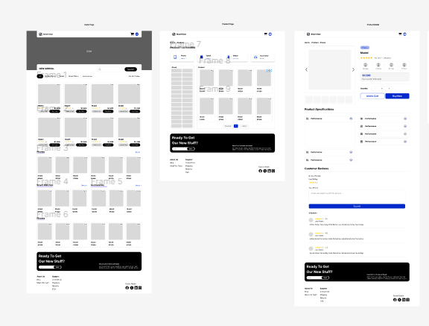

*Figure 22: user view mcokup design*

This Figure 22 Figma mockup design outlines the user interface for an our online phone shop website. It features three key screens that represent a typical online shopping journey:

* **Homepage:** The initial landing page, designed for discovery. It includes a header with search and cart, a large promotional banner area, sections for "New Arrivals" and various product grids, a newsletter signup, and a standard footer.
* **Category/Product Listing Page:** A screen for browsing products within a specific category (e.g., "Electronics > Audio"). It features consistent navigation, filtering and sorting options, a grid of relevant products, and elements like pagination and the newsletter signup.
* **Product Detail Page:** This page provides in-depth information about a single product. It includes a product image gallery, detailed product information (name, price, ratings, color/quantity selectors, add-to-cart/buy-now buttons), specifications, customer reviews, and the recurring newsletter signup and footer.

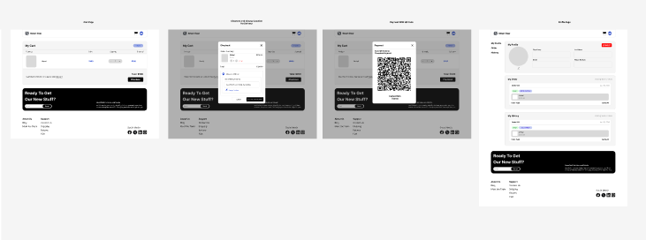

*Figure 23: user view mcokup design*

This Figure 22 is a Figma mockup design outlines key user interface screens related to the our platform's transactional and account management functionalities. It features four distinct screens that represent critical steps in the post-product selection journey:

* **My Cart Screen:** This initial screen displays the user's shopping cart. It includes the items added, with placeholders for product details, quantity, and price, along with options to adjust or remove items. Below the item list, an order summary provides a breakdown of costs (subtotal, shipping, discounts) and the grand total, culminating in a clear "Checkout" button to proceed. A consistent header, newsletter signup, and footer are also present.
* **Payment Method Selection (Modal Overlay):** This screen shows a payment modal appearing as an overlay on the "My Cart" page. It offers various payment options, including input fields for credit/debit card details and placeholders for digital wallet choices, all leading to a "Pay Now" button.
* **QR Code Payment (Modal Overlay):** Another payment option is presented as a modal overlay on the "My Cart" page. This modal features a large QR code, indicating a mobile payment method where users would scan the code with their device to complete the transaction, accompanied by guiding instructions.
* **My Profile Screen:** This screen is dedicated to user account management. It features a consistent header and a navigation area for different profile sections. The "My Profile" section displays personal user information such as a profile picture placeholder, name, email, and contact number, with editable fields. Below this, a "My Orders" section lists past purchases, showing key details like order number, date, total amount, and order status, with an option to view more details. The recurring newsletter signup and footer are consistently included.

**2.Admin or seller View mockup Design**

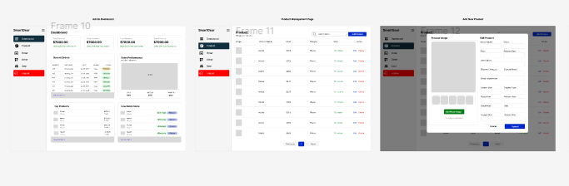

*Figure 24: seller view*

This Figma mockup design outlines key user interface screens for the administrative dashboard of an our platform, enabling store owners or administrators to manage operations. It features three distinct screens that represent essential functionalities for backend management:

* **Admin Dashboard Screen (Frame 10):** This initial screen serves as the central hub for administrators. It includes a left-hand sidebar navigation with links such as Dashboard, Products, Order, Users, Settings, and a prominent Logout button. The main content area displays key performance indicators (KPIs) like total sales, total orders, and average order value. It also features sections for "Recent Orders" with details on order ID, date, customer, and amount, and "Sales Performance" with a chart placeholder. Further sections like "Top Products" and "Low Stock Alerts" provide quick insights into inventory and popular items.
* **Product Management Page (Frame 11):** This screen is dedicated to managing product listings. It maintains the consistent left-hand sidebar navigation. The main area features a search bar for products and a table-like display of product information. Each row in the table includes fields such as Product ID, Name, Category, Price, Stock, and action buttons for "Edit" and "Delete." A pagination control is present at the bottom, indicating the ability to navigate through multiple pages of products.
* **Add New Product Modal (Frame 12):** This screen, shown as an overlay over the Product Management Page, is a modal window designed for adding new products. It provides input fields for various product attributes, including Product Image upload, Product Name, Price, Description, Category, Quantity, and other specific details like Unit Type, Discount, Dimensions, and Weight. Buttons for "Cancel" and "Submit" are included to manage the process of adding a new product.

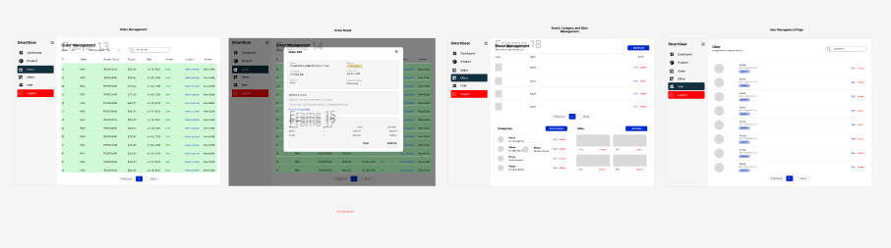

*Figure 25: seller view*

This Figure 25 It features four distinct screens that represent essential functionalities for backend management:

* **Order Management Page (Frame 13):** This screen is for overseeing customer orders. It features the consistent left-hand sidebar navigation. The main content displays a table of orders, likely including details such as Order ID, Date, Customer Name, Total Amount, and Order Status, along with action buttons to "View" or "Edit" orders. Filtering and search options are available at the top to help manage orders efficiently.
* **Order Detail Modal (Frame 14):** This screen is presented as a modal overlay on the Order Management Page, providing detailed information for a specific order. It includes fields for Order ID, Status, Customer Information, Shipping Address, and a list of Ordered Items with their respective quantities and prices. Buttons to "Update" or "Cancel" the order are provided.
* **Teams, Category, and Store Management (Frame 15):** This screen provides controls for various administrative sections. It includes the standard sidebar navigation. The main area is divided into sections, likely for "Teams Management" (managing user roles and permissions), "Category Management" (adding, editing, or deleting product categories), and "Store Management" (settings related to the overall store configuration, such as payment gateways or shipping methods). Each section appears to have lists or tables with options to add, edit, or delete entries.
* **User Management Page (Frame 16):** This screen is dedicated to managing user accounts on the platform. It maintains the consistent left-hand sidebar navigation. The main content displays a table or list of users, including details like User ID, Name, Email, and Role, along with action buttons to "Edit" or "Delete" user accounts. A search bar and pagination are also present for efficient user management.